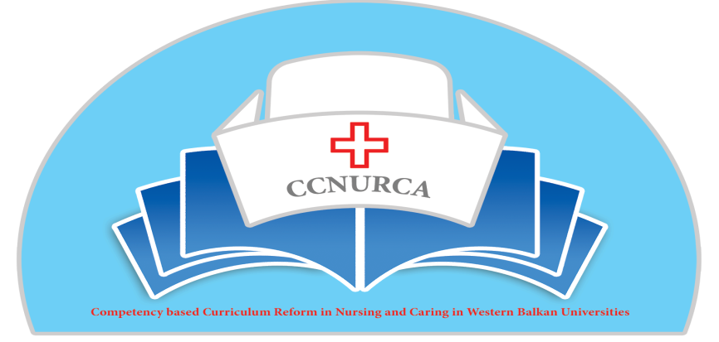
544169–TEMPUS–1–2013-1-BE-TEMPUS-JPCR
Competency based Curriculum Reform in Nursing and Caring in Western Balkan Universities

Pilot project introduction of new teaching and assessment methodologies on nursing program Medical faculty, University of East Sarajevo
During trainings organized inside CCNURCA project (specially after training in Shkodra) we formed a teacher core group for the introduction of new teaching and assessment approached on our nursing program.
We are planning three studies to perform at Medical faculty Foca nursing program.
We plan to introduce PBL, Payton 4 steps methodology, Clinical skills and OSCE station at three different programs: Pediatrics and Care of Healthy and Sick Children, Internal Medicine and Internal Patients Care Ecology and Public Health
The first study will be consisted of students in their second year of nursing study program from the Medical faculty of Foca attending the pediatric course. Around 40 students will be involved . Students will work with three PBL cases, will perform 4 skills using 4 step Payton methodology and five OSCE stations. .All students will be divided in the small groups, 5-6 students per group. Sessions lasted for 1,5 hours and were lead by out trained tutors. After working through teach methodology, students will be asked to fill out a questionnaire, comparing new teaching and assessment methodologies (as new method of teaching) with the classical methods of teaching students were used to. The classical methods consisted of bed side teaching, seminars and theoretical teachings. This questionnaire will be specially designed for this purpose. It compared both the classical and new approach, student’s motivation after the classical and new exercises, cognitive presence, overload during both approaches, and development of different skills and utility of the exercises.
The second study will be consisted of students coming from the third year of study and were involved in internal medicine course. 30 students will be involved in this study. All students will be divided in small groups, 5-6 per group and work on each case for 1,5 hours. Students will be asked to fill out two different questionnaires: one questionnaire concerning the design of cases and one concerning the curricular integration of new teaching and examining approaches. Factors evaluated included questions concerning the learning tool, authenticity of the assignement, and professional approach. In processing of data we plan to use Kolmogorov-Smirnov. This test will be used to check if a sample comes from a population with a specific distribution. For calculating average value, we will use median and interquartile range in case of asymmetric distribution and arithmetic mean and standard deviation in case of symmetric distribution of variables. For comparison of two asymmetrical distributed variables we will use Mann-Whitney U test and for comparison of more than two variables we will use Kruskal-Wallis test. Student T Test will be used for comparison of symmetrical distributed variables.
The third study group consisted of students coming form fourth year attending the course of public health. 30 students will be involved. Students will be divided into small groups. In the end of the pilot project they evelaute teaching process on the same way as previous two groups.
On all three departments we will use same number of cases per methodology .
Start date will be Novemebr 2015 and end date June 2016

