Minutes of the Training and Consortium meeting Groningen
544169–TEMPUS–1–2013-1-BE-TEMPUS-JPCR
Competency based Curriculum Reform in Nursing and Caring in Western Balkan Universities
Dates: 11-12.04.2016
Venue: Hanze Hogeschool-Nursing school Groningen.

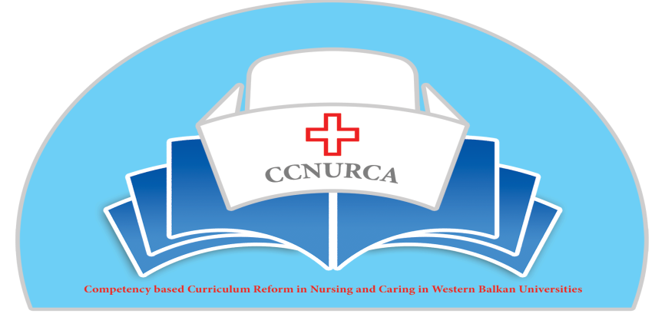
Activity: Practical training in nursing and meeting of consortium

Groningen, 11-12 April, 2016

In Groningen, 11-12 April, training activity and consortium meeting were held within TEMPUS project CCNURCA ''Practical training in nursing, knowledge exchange between EU and WB partners.'' The meeting was attended by 26 participants from all partner institutions.

The main topics of the training were:

- Healthy ageing –modern concept
- Global health and confident self
- Innovations in health care-e health and technology in health
- Competences of nurses-future perspectives
- Research in health care
- Consortium meeting
(see Agenda in Annex 2)

Meeting Day 1; 11th April 2016

- The meeting started with a welcome and the presentation of the agenda. Representative of hosting institution, University of Groningen, H. Van der Werff welcome all participants and gave presentation about this University. After him Mr Willem vanden Berg also welcomed all participants on behalf of coordinating institution, Odisee and in the end Mr Dejan Bokonjic presented the agenda. The agenda was adopted and accepted by all participants.
First presentation was given by mr Paans who spoke about nursing diagnosis. He described in details importance of establishing nursing diagnosis, their connection with nursing treatment plans. He also described difference between nursing and medical diagnosis. After him participants listen presentations about different topics like helathy ageing presented by mr Degenaar, learning community's by E. Hagedoorn; Bachelor nursing 2020 by J. Pelicaan; Advanced nursing practioners by A. Bosch and blended learning by L. Oziel. After each presentation many questions were raised and discussion was very vivid. Hosting institution gave us very nice overview of current situation in nursing and future trends in Holland. For all participnats it was very important to see what are possibilities to introduce those important topics for developemnt of future projects.
- Concluding remarks were made by Prof. Dr. Dejan Bokonjic and Mr Mirza Oruc who stated that the given presentations and observations lead them to new visions and ideas that can be transferred to the WB partner universities.

Meeting day 2; 12th April 2016

- This second day started with a brief explanation of the day program, followed by consortium meeting.
- First lecture was given by Mr Masic who described briefly all implemented project activities and compares them with planned activities. In the end of is presentation all partners got clear picture what should be still done by the end of the project.
- Second topic was about financial situation. Willem va den Berg from Odisee pointed out some financial and technical issues. Partners had opportunity to clarify financial issues with Willem.

Third presentation was given by Mr Oruc, who spoke about importance of dissemination and sustainability of project activities. He described in the retrospective way, all what partners did for dissemination of this project like (interviews, conferences, publications, articles in journals and newspapers and etc.). Also Mr Oruc gave instructions for developing of sustainability plan and what can be approach for maintaining results of our project. Importance of alumni organizations and stakeholders were emphasized.
Next presentation was given by André Govaert who spoke about preparation of self- assessment report, criteria and indicators, methodology of work and responsibilities of partners. Each partner will have obligation to prepare SER according to presented standards except chapter results and some indicators inside chapter connected with students. Each partner institution will select team for preparation of report and will follow instructions. All criteria and indicators are clearly described in Mr Govaert presentation. Also one part of this presentation was focused on organization of external visitation and on accreditation protocol.
Next set of presentations was dealing with legislation frame in area of nursing. Mrs, Jasminka Vucković, Radmila Pejic, Zeljko Bodul and Valja Ljesevic-Dedic, as representatives of relevant Ministries from WB countries, gave strong support for changing and reform of our nursing curricula according to EU directive for specially regulated professions. They spoke about problems in WB countries concerning regulations and position of nurses. Competence based approach is modern concept and is very welcomed in our nursing education. New developed curricula by our Nursing schools are completely supported by our Ministries.
After presentations by Ministries Mr Oruc presented Catalogue of knowledge and skills and nursing procedures. First draft was developed by WB partners and plan is that this draft should be sent to EU experts for comments and suggestions.
After this all partners briefly presented current status of pilot projects they are running on their institutions. Each partner institution describes once again pilot project, evaluation measures and main aim. Some partners will measure part of the running new curriculum and some will test some teaching and examining methodologies through pilot project.
André Govaert presented monitoring report for all WB Universities except University of Korza, which will be visited in the next two months. He gave clear recommendations for improvement and suggested what should be still done until the end of our project.

- The training ended with concluding remarks from Prof. dr. Dejan Bokonjic. He stated that the preconceived progression was accomplished and shared the dates of the following activities:
    - Foca: 02.06.16 : consortium meeting
    - Monitoring Korca-04.06.2016
    - External evaluation BH and Montenegro 03/07.10.2016
    - External evaluation Albania14-17.11.2016
    - Dissemination conference March 2017
- Deadline for the partners to finish selected pilot projects is 01.06.2016. Each WB partner should prepare internal assessment report by July 2016 (without chapter 7-results and chapters 4.6 and 4.7). First results should be presented during Foca meeting. After this project steering committee will select external evaluation team who will perform external assessment of study programs and deadline for reports is end of July 2016. We agreed to update web site of the project and to publish all dissemination activities by 01.07.2016. Next newsletter will be prepared in June 2016. During meeting as we said we presented Catalogue of knowledge and skills and procedures. Consortium members decided that final proposal of catalogue should be presented on Foca meeting.
- During consortium meeting we also discussed about necessity of establishing close bilateral contact between WB and EU partners. This should be very important for sustainability of project results and for continuation of cooperation of project partners after ending of the project.
- Consortium also agreed that it would be important to ask our Officer in Brussels for prolongation of our project until April 2017 so that we have enough time for finishing all predicted activities like external reports and for preparation of final report.
- All partners should finish also first draft of sustainability plan before Foca meeting. Sustainability plan should contain plans for continuation of project activities after ending of the project.
Rest of quipement should be bought in the next two months. Every partner should forward staff costs ASAP.
- The partners of the West Balkan expressed their positive feedback on the meeting organized by University of Groningen and thanked the staff that contributed to this event
- Meeting was perfectly organized by Mr Martin Kaaijk and Mr Johan Van Wieren and their team

Meeting minutes –steering committee, April 2016

