Minutes of the consortium meeting
544169–TEMPUS–1–2013-1-BE-TEMPUS-JPCR
Competency based Curriculum Reform in Nursing and Caring in Western Balkan Universities
Dates: February 9 – 11, 2015
Venue: University of Prešov, Faculty of Health Care, Slovakia

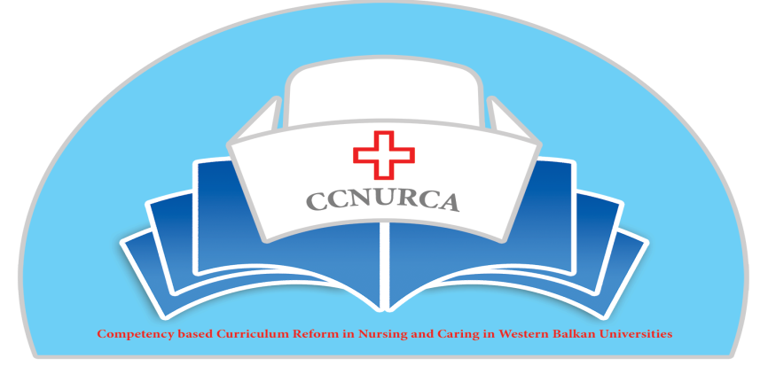

Activity: consortioúm meeting

Prešov, 9-11 February, 2015
The University of Prešov, Faculty of Health Care organized a consortium meeting on the 9th – 11th February, 2015 as a part of the project 544169–TEMPUS–1–2013-1-BE-TEMPUS-JPCR: Competency based Curriculum Reform in Nursing and Caring in Western Balkan Universities
February 9th, 2015
The meeting was attended by 48 participants from EU, partner institutions in the project and representatives of FAMI foundation.
The meeting was opened by the hosting institution. On behalf of host institution Ass.Prof. Stefania Andrascikova welcomed all participants. Rector of University of Prešov Prof. René Matlovič very briefly introduced University of Prešov. Stefania Andrascikova introduced Faculty of Health Care and Dr. Gabriela Kuriplachova introduced new curriculum of nursing at the faculty.
Representative of project coordinator institution Odisee, Mr. Filip Dumez, welcome all participants.
The programme and agenda was explained by Prof. Dejan Bokonjic from Universitz of East Sarajevo.

The main topics of first day of meeting was:
- Presentation by partner`s universities what is achieved, what is changed, what should be done, impression and satisfaction about whole project
- Suggestion for improvement in CCNURCA project
- CCNURCA project activities performed until now
- CCNURCA dissemination, publishing activities
- External evaluation of project achievements
- Financial overview project
- CCNURCA work plan for next two years
- Training program in June in Bosna

Mrs. Kristina Vidovic presented activities and main benefits in CCNURCA project for University of Mostar. She introduced study program, new curriculum, competences.
Mr. Mirza Oruc presented what was done in the project at the University of Zenica. He presented analysis of competency oriented curriculum, team for curricula reform, equipment for new nursing skills lab and training center at the university.
Prof Bogdan Ašanin presented current status of curricula, learning outcomes and matrix of competences at the University of Montenegro. He explained study regulation, process of evaluation, assessment and grading at the university, compare the old and new curriculum, gave detailed view at the curriculum, practical training and evaluation methods. He introduced all changes what they have done at university for reforming nursing curriculum.
Ardian Cerava form University of Korca presented progress of the CCNURCA project in Albania. He referred about all partner universities from Albania, where they decided create and apply one common curriculum.
Mrs. … from University of East Sarajevo introduced four years nursing curriculum, compulsory, optional and elective courses, and internship in the list of subject and detailed hours analysis.
At the end of this block, Mr. Filip Dumez presented summary of work plan activities, positives of the presented curricula and suggestion for improvement, which were recommended EU partners. As good points he mentioned:
- Good clear presentation of matrix
- Clear changes old-new
- Increasing internship
- Variation in internship
- Good respect of EU rules (hours)
- Sufficient clinical practice
- Adjusted syllabus
The points for improvement:
- Nursing leadership should be more visible – reduce number of medical subject, competences should be cleared, integrate theoretical and practical courses
- Integrate periods of internship
- Integrate research in nursing
- Define practical clinical training details - where, who will be guide, role of the workfield in the hospital
- Use of digital learning platform
- Define competences of teachers, their qualification, and criteria
- Define where you use ECTS 25 / 30
- Define evaluation by students, role of students in implementation / change of curriculum
- Define learning methodology and way of assessment
Next part of the meeting was aimed at management of the project and project work plan. Filip Dumez summarized task for WB partners for next period.
By the end February 2015 every partner from the WB will:
- Have a reviewed description of the learning outcomes and educational objectives
- Has finalized the new curriculum, including ECTS
- Has a description on how to train practical nursing skills
- Have (for each year and each course) a description of
    - Content
    - Learning material (books, courses)
    - Work form (teaching methodology)
    - Evaluation (type of assessment, way of assessment, period)
- Have an implementation plan
- Demonstrate their reformed curriculum and implementation plan to
    - the respective ministries (regional accreditation)
    - the EC delegation (validation)
- Be prepared for an ‘pre -audit’

Mr. Srdjan Masic presented status of the purchasing of equipment and dissemination activities. He informed about preparing 2nd CCNURCA newsletter, preparing promoted printed and others material (flyers, keyrings), status of the WB web sites and preparing facebook web site of the project. He evaluated procurement of equipment, which is mostly completed, in Montenegro in progress. After consortium meeting it is necessary for all WB partners to start with using equipment – phantoms, manikins etc. He advised to do dissemination activities, meetings etc. and make reports by all partners what should be done during project life time.
Prof. Andre Govaert from KU Leuven, external project auditor, presented results of his external evaluation of the project achievements since February 26, 2014 to February 9, 2015. He mentioned that number of project consortium partner number in present time is 18. He evaluated main goals of the project, and project work plan activities which were realized in the one year period. He advised to publish each activities on the project web site, finish the first draft of new competence based curriculum WB partners, present and discussed it. He commented capacity building of the nursing schools – equipment for training, teachers training, dissemination activities and commented workplan activities for next year. Finally, he informed about results of the audit in Montenegro and Albania.
Financial overview of the project-status of staff and travel costs was presented by Mr. Willem fanden Berg. His presentation consisted of analysis of new budget table, analytical account, travel and subsistence, and staff cost.
Prof. Dejan Bokonjic invited to participants Work plan activities for second and beginning of the third project year, and main points and ideas of the teacher training workshop in June in Bosna and Hercegovina and in Albania. The next training meeting will be take place in September in Skhodra. Content of the trainer session will be focused on clinical leadership for nurses and integrating practical and theoretical courses, using problem based learning and clinical classes, simulation based training, team training and OSCE evaluation.

10th February, 2015

Second day of meeting was led by Mr. Mirza Oruc. First part of the meeting was training.
Training was started with presentation about overview of teaching methodologies, presented by Mrs. Lubica Rybarova from University of Prešov. She focused her presentation on the methodology for theoretical education in nursing. She made review of the using methods, advantages and disadvantages traditional and innovative methods such as lecture, group teaching strategies e.g. role play, snowballing, Jigsaw, problem-based learning, simulation, problem mapping and possibility for using distance learning methods.
Mr. Maarten Kaaijk from HANZE Universitz of Groningen presented portfolio for internship used in HANZE. Firstly he introduced curriculum development in historical perspective, and view of the portfolio development for evaluation of student`s competences in the clinical training environment.
Mr. Johan van Wieren form HANZE University of Groningen continued in the presentation and explain principles of examination and assessment practical competences at the HANZE. Detailed describe length of the practical period in the nursing curriculum, placement and schedule during 2nd, 3th and 4th year in nursing study program. He explained competence cyclus, plan of the competence development and assessment, such as criterion based interview. Thank You for interesting presentation.
The meeting was continued in afternoon in groupwork.
Participants from each WB countries work with EU experts.
- Group from BH (University of Mostar, University of East Sarajevo and University of Zenica)-Experts from Belgium
- Group from Albania (University of Korca, University of Gjirocastra, University of Skhodra) Experts from Netherlands
- University of Monetenegro-Experts from Slovakia
Each group worked on analyses of curricula, matrix of competences and sylabi of the courses. Representatives of each grupe presented outputs of their day work.
See Minutes from group work
Working day was concluded by Mr. Filip Dunez.

11th February, 2015
Groupwork was continued, leading by EU experts. After that representatives from all WB partners and EU experts presented impressions and satisfactions of group work.
Meeting was finished by Mr. Mirza Oruc, who concluded tasks and deadlines for pratners concerning developing of curricula and introducing competences.
- All partners have to send matrix of curriculum and comptetnces, cours list, study plan, and syllabi no later than the end of February 2015 – discus with EU experts
- Next meeting – teacher training will be take place in Skhodra, Albania in September 2015 – prepare agenda
Thank You all participants, consortioum partners and coordinator team for good job.

Prešov, February, 2015
Lubica Rybarova

