Minutes of the 3th Training
544169–TEMPUS–1–2013-1-BE-TEMPUS-JPCR
Competency based Curriculum Reform in Nursing and Caring in Western Balkan Universities
Dates: 13-15 October 2014
Venue: Odisee (former HUB-KAHO), Campus Waas, Sint-Niklaas.

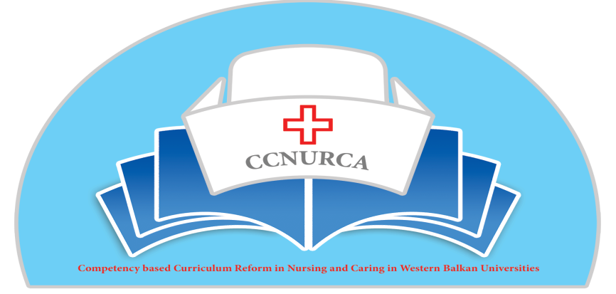
Activity: Practical training in nursing; knowledge exchange between EU
and WB partners.

Sint-Niklaas, 13-15 October, 2014

In Sint-Niklaas, 13-15 October, training activity was held within TEMPUS project CCNURCA ''Practical training in nursing, knowledge exchange between EU and WB partners.'' The meeting was attended by 31 participants from 11 partner institutions.

In the composition below, one can find the list of participants of the meeting in Sint-Niklaas.

Besides the consortium members, there was also a delegation from Fondacija FAMI. In this way, the CCNURCA consortium takes its responsability towards the Memorandum of Understanding (MoU) between CCNURCA and the Proses project 'Strengthening Nursing in Bosnia and Herzegovina' (see Mou in Annex 1)
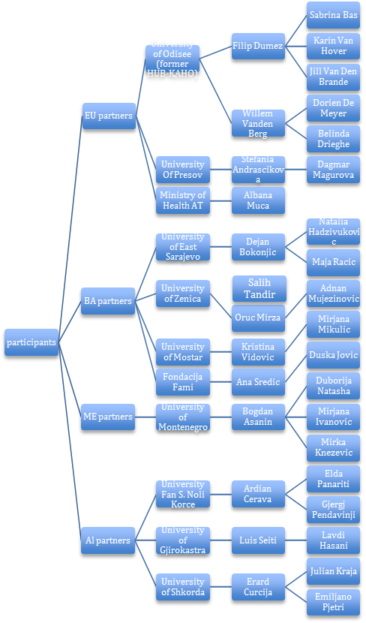
Legend: BA: Bosnia and Herzegovina
ME: Montenegro
AL: Albanië

The main topics of the training were:
- Training and knowlegde exchange of practical training in nursing between EU and WB partners.
- Training and knowledge exchange of the assessment in practical skills in nursing between EU and WB partners.
- Management of practical competence training for nursing students.
- Peer coaching.
- Organisation of internship.
- Workplace training and –learning.

(see Agenda in Annex 2)

Meeting Day 1; 13th October 2014

- The meeting started with a welcome and the presentation of the agenda. Representative of project coordinator institution, Odisee, Filip Dumez, presented the agenda. The agenda was adopted and accepted by all participants.
Mr. Dumez then gave a presentation of the campus. Afterwards all participants were invited for a tour on the campus and the nursing skills lab. The guided tour was presented by representatives of the Odisee campus Waas; Belinda Drieghe, Dorien De Meyer and Jan Standaert. The host institute gave a brief presentation of 'the organisation of the skills lab'.

- Afterwards, Belinda Drieghe and Dorien De Meyer gave a presentation about 'Engaging students in practical training'; starting with a short explanation about ECTS and tolerance. The main goal was to illustrate how students need to prepare themselves for practical training in Campus Waas, Odisee. Educational material was presented and shared.

- After lunch, Belinda Drieghe and Dorien de Meyer gave a theoretical interpretation of practical training, stating out the 5 keypoints used in Odisee, campus Waas.
    - Record of attendance
    - Theoretical part
    - Practicing: student to demonstrate
    - Feedback during demonstration
    - Practicing in small groups

- All participants were invited to observe a live practical training with students. Occasionally for CCNURCA this training was given in English. In the first part, the total group could observe how the theoretical part was realised in training. During the second part; students demonstrated their skill and teacher gave feedback.

- During the reflection on the practical slkills training four questions were asked.
    - First impression?
    - What was striking?
    - Difference in teaching?
    - What's usefull for your own education?
Mirza Oruc, representative of University of Zenica stated out that the level, the quantity and the standard of materials used in this campus were uncomparable with the materials they can provide in their own University. The consequence is that procedures may differ, but basic principles remain (e.g. sterility).
Another difference was the way of teaching. Where students in Odisee first study their material on videos provided by Odisee, in University of Zenica, the practice instructor first demonstrate the procedure whereafter students practice. The most usefull experience was the feedback between teacher and student during practice.
Prof. dr. Dejan Bokonjic mentioned that the big difference is the way of acquiring skills. In his University the ‘4 step-Payton’ approach is used, which involves: demonstration, deconstruction, learner comprehension, learner performs.
Prof. dr. Bogdan Asanin from University of Montenegro concludes that the major difference is the use of materials for practice. Students at his University perform their procedures on patients earlier in their learning curve, due to shortage of teaching materials.
Present students were asked to give their opinion on the skills lab. All students were positive. Another question was if students experienced training practical skills as a blame free environment in contrast to assessment. All students reacted affirmative.

- Dorien de Meyer en Belinda Drieghe then gave a presentation about 'Assessing practical skills: intermediate and final'. The main topics of this presentation were:
    - Practical examination and the difference between 1st, 2nd and 3rd year students
    - The use of a 'checklist'
    - The content of proffesional skills
    - Practical skills
    - Medical count or nursing calculations
    - Converting grade
    - Grade proffesional skills
    - Progress test
A translated checklist was provided for all participants. This checklist 'Evaluation criteria proffesional skills- second training phase: Uninary catheterisation' is based on scientific research. It tends to obectivify and standardize evaluation.

- Concluding remarks were made by Prof. Dr. Dejan Bokonjic who stated that the given presentations and observations lead them to new visions and ideas that can be transferred to the WB partner Universities.
Filip Dumez asked all participants to fill in the evaluation form, so the University could use this feedback to improve later meetings.

Meeting day 2; 14th October 2014

- This second day started with a brief explanation of the day program, followed by a demonstration of practical skills training and assessment.
Belinda Drieghe and Dorien De Meyer did a role play ‘student –teacher’. In this role-play the checklist was used. Afterwards they explained how they agree upon the grade the student would get during this this assessment, using the checklist. Participants could follow everything because of the offered translated checklist.

- In the afternoon partners from WB were invited to demonstrate a practical skill training and assessment whilst using the checklist. In the morning time was offered to prepare the practical training. Placing a nasogastric tube was chosen as subject. Participants were split in small groups and training and assessment was demonstrated by Mirza Oruc and Natalija Hadzivukovic (Team University of Zenica) and Dejan Bokonjic and Duska Jovic (Team University of East Sarajevo).
Afterwards all participants reflected on the training and assessment.

- Also a small change in agenda was proposed due to the numerous questions that were asked in between. To centralize these questions the proposition was to stay in small groups and all WB partners could have their questions answered. Dorien De Meyer and Belinda Drieghe offered all participants a list of courses given in Odisee and a weekly time schedule for students. Everyone adopted the change of agenda.

- Belinda Drieghe and Dorien De Meyer gave a theoretical course upon ‘management of practical competence- training for nursing students’. Main topics were:
    - Competence management
    - Goals
    - Tasks
    - Theme days
    - 3-day trip

- Afterwards Dorien de Meyer and Belinda Drieghe presented a course about Peer coaching or year exceeding coaching. Main topics were:
    - Preparations
    - Expectations of the 3rd year students
    - Benefits for the 1st and 2nd year students
    - Role of the lector
    - Grade

- Concluding remarks were made by Prof. dr. Dejan Bokonjic and Filip Dumez and some practicalities were pointed out. An evaluation form was offered.

Meeting day 3; 15th October 2014

- This last day the final three topics were presented. The first one was the organization of internship, presented by Belinda Drieghe and Dorien De Meyer. Main topics were:
    - European guidelines
    - 1st year students
    - 2nd year students
    - 3rd year students
    - internship
    - workplace training area
    - task
Second topic was about ‘work place learning’. Here the main topics were:
    - What is work place learning?
    - Characteristics
    - Objectives and results
    - What do we expect from the cooperative hospital?
    - Advantages for the hospital
    - Advantages for the student
    - Role of the mentor
    - Preparations for work place learning
    - Follow up
    - Pitfalls
    - Experience
    - Added value
    - Evaluation
    - Conclusion: work place learning is a great investment for all nurses and a huge added value for students. Work place learning is always a pilot project. All problems should always be discussed a.s.a.p. and then dealt with.

- Willem vanden Berg from Odisee pointed out some financial and technical issues. The partners was offered opportunity to clarify financial issues with Willem.

- The training ended with concluding remarks from Prof. dr. Dejan Bokonjic and Filip Dumez. They stated that the preconceived progression was accomplished and shared the dates of the following training and consortium:
    - Groningen (Nl): 17-19/11 : practical training on feedback and assessment, internship and workplace training
    - Montenegro: 10-13/12: steering committee on evaluation of progression on curricula, dissemination and publication plan
    - Presov (SK): 8-12/2: practical training on mentoring, coaching, workplace involvement
The deadline was set for the partners proposal of the curriculum: december 2014. Every partner can choose it's own metholdology but competences should be the ones preconceived. Equipement should be bought in November and ordered at last at the end of october. Every partner should forward staff costs before 2015.
- Mirza Oruc, representative of University of Zenica, emphasised the importance of dissementation. A newsletter will be made by him. He asked that every partner would link the CCNURCA website to the parnter University website. When help is needed, he can be contacted. All partners were askes to mail the practicalities to Johan van Wieren representative of Hanze University of Applied Sciences Groningen before the next meeting in Groningen.

- Filip Dumez and Mirza Oruc explained about the opportunity for students from the West Balkan to participate on the ‘Tour of Flanders’. This is a 2 week course on different subjects in nursing that is organized in Flanders for students from abroad (first 2 weeks of march 2015). The involvement of students is highly recommended (cfr. Recommendations after the audit by Tempus officer). Therefore every partner is invited to send one student to the Tour of Flanders, financially supported by the project. Mirza will send selection criteria for the students to the partnering institutes.

- Filip Dumez handed everyone a goodie bag filled with nursing materials used in skills lab and a certificate of attendance for the practical skills training offered by Odisee.

- The partners of the West Balkan expressed their positive feedback on the meeting organized by Odisee and thanked the staff and students that contributed to this event

Meeting minutes by Sabrina Bas (student 2VE VCM2i); Filip Dumez (Project manager CCNURCA; Lecturer – Researcher Health Care)

