Minutes from the Steering committee meeting
544169–TEMPUS–1–2013-1-BE-TEMPUS-JPCR
Competency based Curriculum Reform in Nursing and Caring in Western Balkan Universities
Dates: 11-12.12.2014.
Venue: University of Montenegro

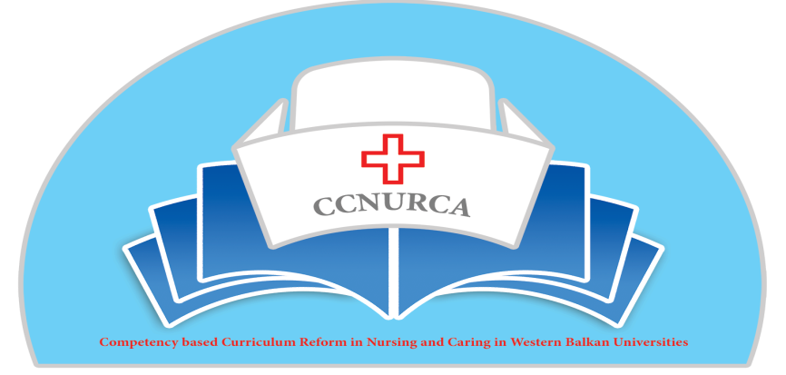

Activity: Coordination meeting-preparation of future activities

Montenegro, 11-12.Decembar, 2014

In Budva Montenegro, from 10-13 Decembar 2014, was organized meeting of the Steering committee in the frame of the Tempus project CCNURCA. The meeting was attended by 12 participants from EU and WB partner institutions in the project
The meeting was opened by hosting institution, University of Montenegro. On behalf of host institution Mr. Asanin welcome all participants. He briefly explained main purpose of the meeting and main goals, which should be reached after two days meeting. After him Mr. Filip Dumez on the behalf of coordinated institution, University College Odisee, thanks hosting university and briefly described what was achieved till now and what should be done in the future. After him Mr. Bokonjic presented agenda of the meeting and continue with presentation about academic activities perfomed till now in the project and what is main focus of different University groups in the moment.

The main topics of the meeting were:
- Presentation of the new curricula-current status,
- Presentation of the learning goals and outcomes of nursing education
- Presentation of matrix of competences
- Current status of syllabi
- Dissemination strategies, sustainability of the project and finding of equipment
- Results of monitoring activities
- Preparation of Presov meeting
- Consultation of WB University representatives with EU mentors
- Administrative and technical issues in the project
- Deadline and responsibilities of all project partners

Academic part of the meeting started with the presentations of representatives of the WB Universities from BH , Montenegro and Albania about current status of curricula. First Mr. Oruc presented situation in BH. He presented nursing curricula from University of Zenica, East Sarajevo and Mostar. Generally Zenica and East Sarajevo are in the final stage of preparation of final draft of curricula. East Sarajevo developed complete proposal with ECTS points and exact ratio between theoretical and practical hours (according to Directive). Number of total hours is close to 4600 what is reccommendation by EU Directive 2005/36 (2013/55) on the recognition of professional qualifications for specially regulated professions. University of Zenica developed final draft, ECTS and ratio of theoretical and practical part will be defined in the next two weeks. University of Mostar is little bhind these two universities. They are working on curriculum but still final draft is not ready. Curriculum on the University of East Sarajevo and Zenica is quite similar.
After Mr Oruc, second speaker was Mr Asanin who presented curriculum from University of Montenegro. Curriculum is prepared as draft version and it is very similar to curriculum already presented by Universities from BH. In their proposal can be found number of teaching hours, ratio between practical and theoretical teachings and ECTS points. All Universities will try to enhance number of student practical hours through summer and winter practice. Number of teaching weeks is 15 per semestar and according to current law is imposible to reach such great number of practical hours without including different typer of interships.
In the end of first session Mr Cerava presented curricula of three Albanian Universities (Korca, Gjirokastra and Shkodra). Albanian Universities are also progresing in the proces of the preparation of the curricula. Mr Cerava presented all three curricula, which are almost the same. Still Universities have to work on connection between competences, learning outcomes and curricula. Finalization of the curriculum will be done by the end of the year. In the end of presentation we had a long discussion wth EU partners about different aspects of presented curricula.
Next presenter was Mr Bokonjic who spoke about sillabi for the different courses and showed template for sillabi, which is going to be sent to all partners as a model. Template is consisting of following parts: Name of the course, course code, is it obligatory or elective, precondition for entering particular course, number of ECTS points, aim of the course, learning outcomes, teaching topics for every week, practical methods, examination techniques, methodology of calculation of ECTS points, list of teaching staff involved in the course and literature. Most Universites in BH already prepared silabi of all courses.
Mr Bokonjic also spoke about matrix of competences, learning outcomes and goals. Each partner will have obligation to prepare matrix of competence before coming to Presov (by the end of December) and on that way to check is there is a connection between final program learning outcomes and courses inside curriculum.
Next speaker was Mr Masic who spoke about results of monitoring visits, and dissemination strategies and sustanability of the project. He emphasized main recommendations got from experts during monitoring. We agreed that we have to enhance our road map by regular updating of this document. Mr Dumez took responsibility to work on updating of existing version of our roadmap. One of the major recommendation was to go into proces of finding of equipment due to delay we had due to misunderstanding of rthe new document-role of origin. Project consortium got clear information from our project officer about eligible equipment we can buy, so all project partners are working currently on finding of the equipment. All three BH Universites, University of Skhodra and Montenegro are in final stage of finding equipment. Other two Universities from Albania already bought equipment.
Mr Masic and Oruc joinly presented different dissemination strategies like: approach to media, approach to different social networks, better connection of the partner web sites with central web page on the coordinator institution, University College of Odisee, producing of different flayers and other adverstisment material. Also Mr Masic presented what each web site should contain: basic facts about project, logo of the project and tempus, link to main web page and etc. Next newsletter will be prepared just after Presov meeting.
Mr Bokonjic spoke about sustanability strategies and main idea is to prepare joint event with Fami foundation concerning Teach the teacher training focusing on teaching and examining methodologies. Training will be organized next year for all nine nursing schools in BH with Fami foundation who will cofinance training. If training succed next training will be prepared in Albania both for Albanian partners and Montenegro partner. Also important thing will be continuation of cooperation with Fami and also with EU delegation Tunning project dealing with nursing education in BH.
The second part of the first working day and second day was devoted to preparation of Presov meeting, preparation for licencing of the programs, adminstrative and finacial issues and work in small groups with EU mentors.
Mrs Rybarova and all partners agreed during meeting about proposal for the agenda for the meeting in Presov. First day during the morning University of Presov will present their nursing curriculum and also teaching and assessment methodologies they are using in teaching process. In the afternoon and next whole second day will be devoted to work in small groups. Each EU mentor is in charge of different University. So groups coming from partner countries together with representatives of Ministries will work ofn the proces of fine tunning of WB nursing curriculum and on connection between courses and final learning outcomes and competences. Last day of the meeting will be devoted to the Consortium meeting. Three representatives of each University will come to Presov plus one representative of each relevant Ministry involved in the project.
Representative of University college Odisee, Willem van der Berg pointed out some technical issues. He clearly explained current financial situation in the project. Expenditures in all categories are explained in details. We are approaching to half duration of the project and we should think about future activities taking into account amount of money predicted for future activities. Also we passed through current situation concerning paper work done in project till now. We concluded that we did a good job, we spent half of the money what is in the complete accordance with predicted activities and future obligations. Also Mr. Willem informed us about interim report, deadline and responsibilities of each partner.
We continue our work discussing with EU partners about possibilities for acceptance of the new curriculum by relevant authorities. Mr Bokonjic explained that after preparation of the final version of the curriculum, it will be submitted to Faculty councils and then to the Senate of the particular University. After approval document will be sent to relevant Ministry for licensing. Also during meeting we devoted some time in clarification of exact role of EU partners in leading different Universities during preparation of curriculum and other important documents.
Representatives of BH, Albanian and Montenegro Universities used time during this meeting to discuss about different aspects of their curriculum proposal, placement of the research and etc.
Next topic for discussion during our meeting was publishing issue. We agreed that we have to publish few articles from material we already developed. Mr Dumez presented options and gave proposals. He will be in charge of the preparation of the first article concerning presentation of the current situation in nursing in the WB region and comparison with EU best practice. Mr. Oruc will prepare one article for one of the next conferences. Also EU partners agree that whenever there is possibility that we present something about our project on conferences organized in their countries to invite somebody for WB countries.
Concerning timetbale of activities next meeting will be organized in Presov from 08-12 February 2015.
We also planned Train the trainer seminar in June 2015. Meeting will be organized in BH. We are waiting for final information about availabily of EU partners. Exact date for additional training for Montenegro and Albanian teaching staff will be defined during Presov meeting.
Next Consortium meeting in September or October next year will be organized on the University of Gjirocastra and Korca.
We also agreed to prepare proposal for catalogue of knowledge and skills and booklet with nursing intructions and nursing diagnosis. Draft document with structures should be prepared till next meeting in Presov when we are going to devide responsibilites among partners.
Extrenal monitoring of the project will be done by Mr Govaert during Presov meeting.
Internal evaluation of the project will be done regulary after every meeting, from the next meeting in Presov.
Curriculum, sillabi of the course and matrix of competences should be delivered to EU mentoring institution and project coordinator by each partner institution by the end of December.
Mr Bokonjic is obliged to send template for sillabus and model of matrix developed by UES in the next ten days.
All project partneres during december should update web page using instructions Mr Masic gave during meeting.
Mr Dumez will sent draft version of article ready for publishing by the end of December
Mr Oruc will prepare paper for conference by the end of January and sent to all partners
The meeting was perfectly organized by University of Podgorica, Prof Asanin and his team.

Project coordinator December, 2014.

