Minutes of the 2st Training
544169–TEMPUS–1–2013-1-BE-TEMPUS-JPCR
Competency based Curriculum Reform in Nursing and Caring in Western Balkan Universities
Dates: 04-07 june 2014.
Venue: University of Zenica, Zenica

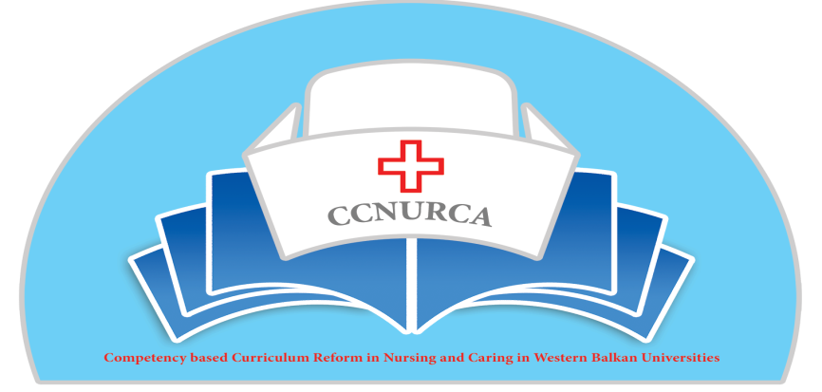

Activity: Setting up learning outcomes for new curriculum

Zenica, 04-07.June, 2014

In Zenica from, 4-7 June 2014. was organized training «Setting up learning outcomes for new curriculum» in the frame of the Tempus project CCNURCA. The meeting was attended by 35 participants from EU and partner institutions in the project and 3 representatives of FAMI foundation. Fami foundation was invited as guest organization. Fami is running project «Strengthening Nursing in Bosnia and Herzegovina», that this organization implements under funds of Swiss Agency for Development and Cooperation SDC regarding nursing reform in B&H. This agency is working on some similar aspects of nursing reform like our project, so we would like to join our acitivities with them, especially not to overlap some of them. We had several meetings with this organization in the past and agreed this strategy with their governing board what is approved by project consortium.
The meeting was opened by hosting institution. On behalf of host institution Mr Oruc very welcome all participants; briefly described University of Zenica and nursing faculty; emphasized importance of the project for reform of the nursing education; described main aims of the meeting and presented all technical issues related to this meeting. After him Minister of ZEDO Cantoon Mrs Balorda also welcomed participants and expressed her readiness to help implementation of the project results. Next speaker was representative of project coordinator institution, HUB KAHO, Filip Dumez. He thanks organizers and presented outputs, which should be reached in the end of the meeting. In the end coordinator for partner countries Prof. Bokonjic presented agenda of the meeting and asked participants to take active role during the meeting and specially during group work. Some small changes in agenda were proposed. The agenda was adopted and accepted by all participants.

The main topics of the training were:
- Presentation of the core nursing competences,
- Presentation of the goals and outcomes of nursing education
- Assessment of the outcomes
- Teaching methodologies in nursing
- Examining methodlogies for the nursing
- Presentation of the temppalte for project road map
- Quality management in nursing
- Creation of competence based curriculum-group work
- Administrative and technical issues in the project
- Deadline and responsbilities for all project partners

Training began with presentation of Prof Govaert who talked about competences in general and quality management in nursing. Prof Govaert clearly explained importance of introducing competence based curriculum and quality assurance measures in nursing curriculum and education.

Training continued with the presentation of representatives of University of East Sarajevo prof. Bokonjic and prof. Racic about competences in the nursing and nursing goals. Mr Bokonjic presented final draft document, which contained 9 core competences and number of indicators necessary for graduate students to reach them in the end of studies. During preparation of this document literature was searched for different groups of competences (knowledge, skills and attitudes), which one modern nurse should posses after finishing of bachelor education. Document was prepared on the way to take into account cultural background of WB countries and system of education. Selected competences we distributed in different groups, which are in accordance with current European best practice in this field. After defining them they were described through different set of indicators, which will help in measuring results. Quite number of participants sent their sugestions during preparation of the document and all of them were incorporated into document. After presentation Mr Dumez commented competences and clarified all unclear things in the document. In the end of the session document was accepted by all partners. Second part of presentation was delivered by Prof Racic. She talked about main goals of nursing education and talked about necessity to define goals before working on the new competence based curriculum.

Next presentation was given by Ardian Cerava representative of the University Korza who talked about outcomes and outcomes delivered assessment. He emphasized that assessment of the competences. which should be adopted according to new approach is crucial for implementing this new way of education.
Prof. Bokonjic druing next presentation briefly talked about matrix of the competences and their connection with courses and outcomes. Also he presented guideline for development of the curriculum cretaed by Councill of Europe in BH. This document can help all participants in preparation of the new curriculum.
Next presentation was presented by representative of University of Zenica mr Oruc. Presentation was about outcomes of nursing education. Outcomes were presented in details. Mr Oruc spoke also about different aspects of nursing curriculum.

After the lunch break the training is continued with the presentation by Filip Dumez, University of HUB KAHO, about project road map. He presented main structure of road map. Road map should be clear guideline for smoothly running of the project. After getting several comments we adopted road map. Main conclusion is that road map should not be an extensive document but should contain brief description of each chapter with links to major developed documents and reports about performed activities.
Representative of University of Presov, Lubica Rybarova analyzed new examination methods. She explained in details different examining methodologies, which are used on her university, and ways of assessing different competences. After her presentation many different questions were raised and we had very fruitful discussion.
In the afternoon all participants were split in six groups. Each group was run by EU mentor. Main aim of group work was working on the preparatory steps for development of the new curriculum. More precisely groups discussed about main principles for developing of new curriculum, different stages for curriculum development and etc. Mentors prepared templates and set of questions which helped participants during their discussion. It was very important that participants got instructions for homework. After going back to their domestic institutions all groups will act as core groups for development of CBC. During discussions they analyse current curriculum, current and future competences in nursing, future directions and etc.
Representative of University of HUB KAHO Willem vanden Berg concluded first day of meeting and pointed out some technical issues.

Second day started with the group work. Groups worked on preparation on the conclusions after first day and make presentations about outcomes of trainings, which were presented by group representatives on the plenary session in the end.

The next presentation was given by Johan van Wieren. He talked about teaching methodologies at Hanza nursing school. Also focus of the presentation was nursing curriculum, outcomes of nursing education and competence based approaches in nursing.

Next presentation was given by prof. Bokonjic, University of East Sarajevo, about matrix of competences and connection of the competences with different courses inside new curriculum. He presented curriculum development good practice guide produced as part of the joint European Commission Council of Europe project 2009-2011 “Strengthening Higher Education in Bosnia Herzegovina (SHE III)“ and showed model that could be used in developing of new curriculum. This model is only proposal for partner institutions, which should be cosidered by all partners.
In the end of the second day Willem vanden Berg and prof. Bokonjic presented dissemination strategies for CCNURCA project. Consortium discussed about other ways of dissemination: newsletter, conferences, seminars, media conferences, publications and etc. Involvement of the Ministries shouls be crucial for the sustanability of project results.
Mr Srdjan Masic presented procedures for finding equipment and how far procedure was introduced in BH, Albania and Montenegro. Procedures are running according to Tempus rules and final offers will be sent to HUB KAHO, who will bring final decissions about way of finalizing this proces.
Concerning timetable of activities consortium accepted final proposal about future activities. All information can be found in the ppt presentation in the annex to this report.
The meeting ws perfectly organized by University of Zenica, Faculty of Health and Mr Oruc and his team Prof Mimica and his team.

Project coordinator June, 2014.

