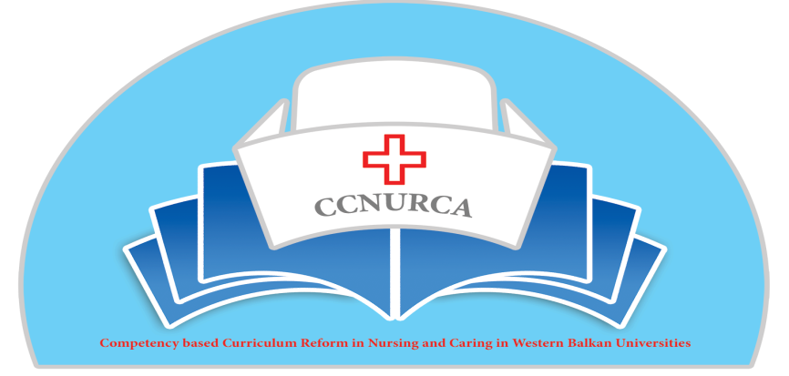
Minutes from the Steering committee meeting
544169–TEMPUS–1–2013-1-BE-TEMPUS-JPCR
Competency based Curriculum Reform in Nursing and Caring in Western Balkan Universities
Dates: 17 November 2015
Venue: University of Zenica.

CCNURCA TEMPUS PROJECT
Sterring commitee meeting Zenica.
Date: 17.11.2015.
Venue: Faaculty of Health Science, Univerzity of Zenica, Zenica Bosnia and Herzegovina
Participants: prof dr sc Dejan Bokonjic (UES), prof dr sc Andre Govaert (KUL), Filip Dumez (Odisee), Maarten Kaajik (Hanze), Lubica Rybarova (UNIPR), Bogdanin Ašanin (MNE), Erard Curcija (ALB), Mirza Oruč (UNZE), Adnan Mujezinović (UNZE), Salih Tandir (UNZE), Željko Bodul (MoEDZDK),

Meeting start with opening speach by mr Filip Dumez in name of Project consortium, Prof Dr sc Dejan Bokonjic in Name of partner countries and mr Mirza Oruč in the name of the hosting institution.
Meeting start with presentation and analysis of project activities done so far by project work plan, and presentation of mr Dumez with participation of all participants. Intermediate report has also been presented.
We analysed project work plan using methodology step by step .We concluded following:
WP 1. is done, with obligation that Road map will be actualized, updated on web page. Parts of road map will be done by partners. All reports made within WP 1 will be printed as documents in booklets. This will be done by University of Zenica. Odisee will prepare project press map.

WP 2 is also analyzed by acitivites with discussion of all participants. Activities 2.1. and 2.2. are finished. Activity 2.3. is partly finalized, all new curriculums will be published on project web site. Booklet will contain each study programme and will be prepared. It is neccessary to invole Alumni and Stakeholders feedback in this process. Until the end of 2015 all new curriculla should be published within booklets with the report on feedback from Alumni and Stakeholders and should be send to Coordinator. Activities 2.4. and 2..5. are finished and all informations on these activities are published on project website.
WP 3 is finished, all predicted trainings are fully conducted with participants involvement. Informations are published on the web site.
WP 4. Capacity building process is still running. First tranche of IT equipment is purchased and installed on partner institutions. Equipment for training centers should be purchased within next tranche. Based on new rules of ECEA it is important that each Faculty collect three offers for themselves, and send to the coordinate taking into account role of origin. Deadline for this activitiy is end of Januray 2016. Software for measurement of Perfomance indicators should be used for estimation of the improvement in the teaching process and will be provided as adititional value to project, so that each Faculty can make presentation on the dissemination conference in Foča, University of East Sarajevo what has been done with implementation of new methodologies and approaches.
WP 5- and WP 6 are in process of implementation in the same time. Methodology that is used for ESABIH tempus project for programe pilot Accreditation will be used, beacuse it is based on ENQA and HEA BiH standards. All templates, methodologies will be updated at web page for all partner universities by the end of year. These WP's will be lead by University of Leuven and University of Zenica.
WP 7. within the activities of this WP consortium suggest that Parnter countires signed agreements with EU partners to ensure connection with partners and sustainability of projects. It is suggested that under the action 7.1. student will participate in activity called Tour of Flanders. Question should be sent to Project administrator in Brussel for eligibility of this plan. For activity 7.2. partner organisation FAMI is obliged and they are conducting activities about law changes in the same time as activity. 7.3. and 7.4. They will be realized by the end of the project and developed guideline will be used for all partner universities who want to change curriculum.
WP 8. is going on currently in BH and Montenegro and it is finished for Alabania except University of Korca. Summary of monitoring visit will be published as report on the web page of the project.
WP 9 is running very good. Web page is developed, newsleeter is developed, info sessions for stakeholders are performed, and dissemination events are organized. Beside planned developed dissemination activities many different activities are conducted like presentation of the project results on International Conferences and through published papers.
WP 10. Managmeent is going smootly.

After presentation of the project WP's, partner representatives gave presentation what was done until now in Partner Countires. On behalf of BiH Universities mr Mirza Oruč presented what was so far done on curricula reform and implementation of project acitivites; prof Bogdan Asanin presented all performed activities in Montenegro, and Erard Curcija made presentation about project activities perfromed by Albanian Universities.
Prof dr sc Dejan Bokonjic has presented catalogue of skills and competencies for nurses, teaching materials for nurses (procedures) that will be finished by end of January 2015. Taching material will be consist of 25 procedures and the guidleine with main skills and will be published on English language. Prof Bokonjic also present multimedia CD from training in Albania, Shkodra that will be used for learning proces on all partner institutions.
Analysis of the budget is also done by Consortium members and it is suggested that concerning travelling four events should be organized for sure in the third project year: 1 student per institution will travel on tour de Flanders, if we get posotove feedback from the commission for organizing this event; Experts from EU partner institution should participate on the dissemination seminars organized on WB Universities; Consortium meeting will be organized in the Groningen with participation of two participants per each institution and Final conference will be organized in Foca, East Sarajevo in june or July 2016. Each institution should send staff conventions, pay slips, time sheets and contracts for second project year to Mr Willem vanden Berg. Also it is important to start working on finding offers for equipment separately for each institution.
It is agreed that next consortium meeting will be organized in Groningen, between 10-14-04.2015.
Meeting is closed by representatives of coordinating and hosting Institution.
Meeting was organized perfectly my Mirza Oruc and his team.

AppendiX.
- Agenda of meeting
- List of participants
- To DO list.
TO DO LIST – SUMMARY:
Update and re-publish road map – Odisee + all partners (filip Dumez) – end of Year 2015
Printing of all reports in booklet – University of Zenica (Mirza Oruč) – End of Year 2015
New curricula of each partner institution published on the web page – University of East Sarajevo (Srdjan Mašić) – End of year 2015
Report on stakeholders and Alumni feedback – University of east Sarajevo (Dejan Bokonjic) – end of year
Dissemination acitivites published on web page – all participants – continously
Equipment purhcase – All partners by end of January 2016
Consortium meeting Groningen 10-14.04.2016
Nursing procedures and catalogue – Mid January first draft 2016 – Mirza and Dejan
Self evaluation reports of new programs June 2016 and external evaluation visits September 2016.
Template for pilot Accreditation published on Web page – KUL and UNZE (Govaert and Oruč ) – end of year 2015
Pilot project road map and Evaluation methodology. – Mašić Oruč, Bokonjic

