Minutes
Train The Trainer session: knowledge exchange between EU and WB partners
544169–TEMPUS–1–2013-1-BE-TEMPUS-JPCR
Competency based Curriculum Reform in Nursing and Caring in Western Balkan Universities
Dates: 20-22 February 2017.
Venue: University of Mostar, Faculty of Health Studies, Mostar

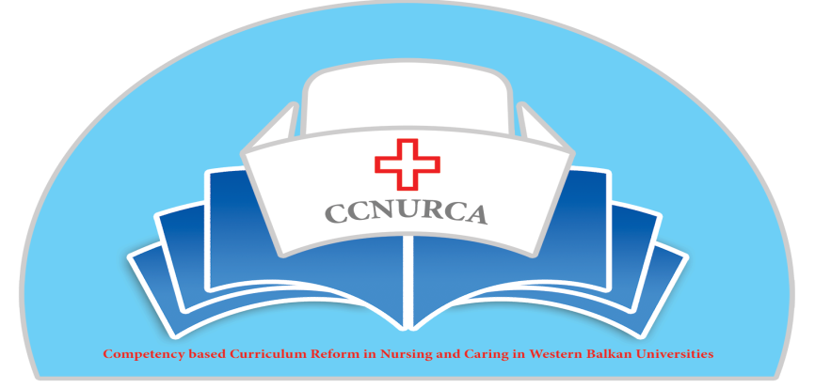

Activity: Fine tuning of new curriculum

Mostar, 20/22 February, 2017
In Mostar, 20/22 February 2017. was held training activity within TEMPUS project CCNURCA “Fine tuning of the new curriculum“. The meeting was attended by 35 participants from 7 partner institutions.
The training was led by project coordinator Hogeschool Odisee. The main topics of the training were:
How to monitoring the implementation of a new nursing curriculum?
What are the pitfalls and the necessary tools,
- Internship? How to evaluate on an objective way
- How to incorporate debriefing, the use of video’s in our new curriculum
At the beginning of the training representatives of partners institutions were greeted by the host prof. dr Vildana Tomic, Vice Dean of the Faculty of Health Sciences, University of Mostar, by representative of University of East Sarajevo prof. dr Dejan Bokonjic and by representative of project coordinator University Willem vanden Berg. They pointed out the significance of this project for academic community and higher education reform regarding establishing of new nursing curriculum in WB partner institutions. They emphasized that this seminar is additional activity organized inside project due to the fact that after creation of new curricula all partner institution asked for training for implementation and monitoring of the program.

Prof. dr Dejan Bokonjić was presented agenda in detail and stated that, apart from ex cathedra teaching, two workshops will be organized about coaching of students and quality assessment. The agenda was unanimously adopted by the participants.
In the end of the introductory part Kristina Pehar, nurse from University of Mostar presented Faculty of Science and describe in details existing new program and future directions of the Faculty of Science.

Training began with the presentation of representatives of Hogeschool Odisee Mrs Gillis who spoke about how to monitor new curriculum. She described in details process of implementation of the curriculum. It is necessary to have clear vision what we would like to achieve in the end. There are different pathways like recognizing, strategic and affective necessary to be followed for implementation of the new curriculum. During the whole process clear communication must be presented. It is important to know what is the content of the curriculum, why are you introducing new curriculum, who is doing that and when is going to start. It is important that all relevant factors had to be involved in the creation of the new curriculum. In the end of the presentation necessary tools for implementation and major pitfalls were presented.

Next presentation was presented by Mrs Drieghe, Homeschool Odisee about internship and how to evaluate it on the objective way. The presentation started with possible ways of organization of the internship. The whole process of internship was presented from skills and knowledges necessary to be gained during practice, through organization of mentorship to evaluation of the whole process. A lot of questions during and after presentation came about Mentors, their expertise and way of their trainings. Also big discussion was held about evaluation of the whole process and role of students.

After the small break the training is continued with the presentation by Mr Torsy, Hogeschool Odisee, about usage of video’s and debriefing inside new curriculum. He showed a lot of good examples how to use new modern teaching approaches for teaching nurses. Participants got links to many interesting videos and platforms for e learning. For education on our schools would be very important to use evidence based nursing skills videos. Mr Torsy also described benefits and possible pitfalls of using videos in nursing education. Debriefing methodology and its role in education was also described in details.

In the afternoon training continued with two workshops. All participants were split in two groups. First workshop was dealing with the quality of assessment. For introducing new curriculum besides creation of the program is it necessary to introduce appropriate teaching and examining methodologies. On WB universities special problem, according to opinion of the most partners, will be introduction of assessment methods appropriate for checking defined skills. During workshop, very nice example how to check quality of the MCQ and written test for student, was presented. All participants took part in this workshop very actively.

Second work shop was devoted to coaching of students or mentors. Through the system of core quality, pitfalls, allergy and challenges it was shown how communications and adoption of behavior is important for proper running of mentorship.

In the end prof Bokonjic, University of East Sarajevo, gave concluding remarks. He made summary of the meeting and organized small discussion about topics covered during meeting.

Mr Oruc, University of Zenica presented plan for final dissemination conference and consortium meeting which will be organized in Zenica from 20-21.03.2017. All participants gave some suggestions fro improvement of the agenda.

The whole meting was perfectly organized by University of Mostar, Kristina Pehar Mladen Mimica and their team.

Mostar, February 2017 Minutes led Dejan Bokonjic

