Minutes from the Consortium meeting
544169–TEMPUS–1–2013-1-BE-TEMPUS-JPCR
Competency based Curriculum Reform in Nursing and Caring in Western Balkan Universities
Dates: 02-03.06.2016.
Venue: University of East Sarajevo-Medical faculty Foca

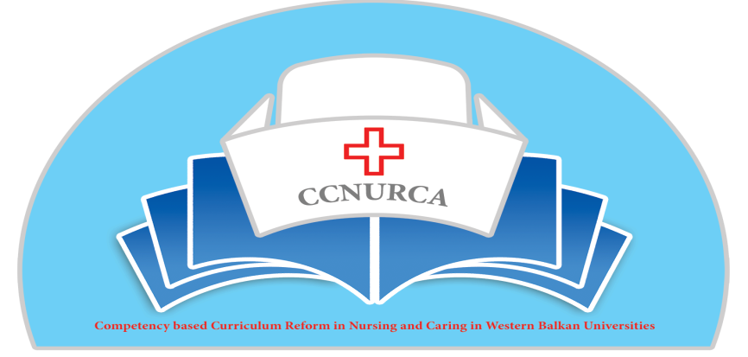

Activity: Consortium meeting-preparation of future activities

Foca, 02-03.June, 2016

In Foca Bosnia and Herzegovina, from 02-03 June 2016, was organized consortium meeting in the frame of the Tempus project CCNURCA. The meeting was attended by 26 participants from EU and WB partner institutions in the project
The meeting was opened by hosting institution, University of East Sarajevo . On behalf of host institution Dean of the Medical faculty, prof Kulic welcomed all participants. He briefly explained main purpose of the meeting and main goals, which should be reached after two days meeting. After him Mr. Willem vanden Berg on the behalf of coordinated institution, University College Odisee, thanks hosting university and briefly described what was achieved till now and what should be done in the future. After him Mr. Bokonjic presented agenda of the meeting and continue with presentation about overview of activities perfomed until now in the project and what is the main job until the end of the project. Prof Bokonjic transfers apologies from University of Korca for not coming to Foca due to the changing of Rector team at this University.

The main topics of the meeting were:
- Overview of current status of project activities
- Overview of financial situation
- Presentation of results of pilot projects
- Dissemination and sustanability plan
- Preparation of the newsletter
- Preparation of the SER-current status
- Presentation of the catalogue of knowledge and skills and nursing procedures
- Upgrading of current web site
- Administrative and technical issues in the project
- Deadline and responsibilities of all project partners

Academic part of the meeting started with the presentations of representatives of the WB Universities from BH , Montenegro and Albania about implementation of pilot project. First Mr. Oruc presented situation on University of Zenica. He presented results of pilot project done on the University of Zenica. They started with new nursing curriculum this semester and also introduced some new teaching and examining procedures. After Mr. Oruc, second speaker was Natasa Duborija Kovacevic, who presented pilot project organized on the University of Montenegro. They introduced the 4 step Payton methodology and tested on the nursing school. Next spekear was Erard Curcija on behalf of the University of Skhodra. He spoke about changing of curricula and also about introducing new methodologies inside curriculum. Next spekaer was Luiz Seiti from University of Gjirokastra who spoke about modernization of teaching proces on nursing school Gjiroakstra and also presented results of the pilot project through which they tested innovations in teaching process. In the end of first session representative of Mostar University, Kristina Pehar and representative of University of East Sarajevo Dejan Bokonjic presented results of the pilot project on these two institutions. Kristina spoke about dissemination of new teaching methodologies on the University of Mostar after seminar in Shkodra and Dejan Bokonjic presented results of two pilot projects one on Pediatric department and one on the Public health department (introducing PBL, OSCE stations and mind mapping). All pilot projects were succesfully implemented on nursing schools.
Next presenter was Mr. Oruc who spoke about dissemination of project results. He emphasized that dissemination of project results is extremely important for implementation of each project. He presented activities done, so far concerning dissemination like current status of the website, different publications, promotion of project results on different conferences, newsletter and so on. He also presented movie about dissemination of project results on the University of Zenica. He kindly asks all BH participants to send dissemination results to him by the 01.07.2016.
After Mr. Oruc and Mr. Bokonjic spoke about matrix of competences, learning outcomes and goals and standards for nursing qualifications.
The Idea was to show how important it is to combine different projects and upgrade current topic and test implemented activities on different ways. In the same time during developing of new curriculum through CCNURCA project we also developed standard of qualification for nursingg on bachelor and master level and a matrix of competences, which is important for integration of the curriculum.
Next sessions were devoted to preparation of SER. Each University presented current status of report. Presenters were (Mr. Oruc, UNZE, Mrs. Racic UES, Mr. Asanin UNMO, Mr. Seiti Gjirokastra, Mr. Curcija Skhodra and Mrs. Pehar Mostar). Session was moderated by professor Govaert. After each presentation professor Govaert gave comments and recommendations for improving report. All Universities did a great job about report and this was more than was expected at this stage. Deadline for finishing of the report is the end of July 2016.
Concerning finding of equipment Zenica and UES from BH; University of Skhodra, Korca and Gjirokastra from Albania and Montenegro are in final stage of finding equipment. Equipment is paid by coordinating institution and delivery will be organized very soon. Mostar is in the process of tendering, still equipment is not paid but we expect to finish this activity soon.
Mr. Bokonjic spoke about sustanability strategies and main idea is to prepare additional trainings for staff, which can be important for sustanability of the project. This depends of the amount of money still left for travelling and this will be agreed soon after final analysis of budget spent for travelling until now.
Mr. Oruc presented final version of catalogue of knowledge and skills and handbook with nursing procedures. He also presented comments got by EU experts until now. EU partners gave some useful comments for improving these two documents, which will be of crucial importance for implementation of the new curricula.
Next set of presentations were devoted to preparation of the sustanability plans for each institution. Mr. Bokonjic in the beginning of the session presented draft idea about sustanability plan for all partners, so after him all Universities presented what they plan to do to make this project sustainable after official ending. Those presentations will help a lot for preparation of final project sustanability plan.
Next presentation was delivered by Carlo van den Bunder, University College Odisee, who spoke about usefulness of web pages and possibilites for enhancing dissemination through web pages and extending services offered by the pages.
First day was finished by final conclusions of Mr. Willem vanden Berg and Dejan Bokonjic about administrative issues and the to do list. Mr. vanden Berg emphasized what is necessary to be send by partners as proof concerning money spent for travelling, costs of stay and for the staff costs. He clearly shows current status of spendings for each Institutions for different budget headings. Mr. Bokonjic reminded once again about some important dates for a good realization of the project working plan and said that final «to do list» will be prepared after final calculation of budget what will be done after meeting in Foca by coordinating institution.
Concerning timetable of activities:
- Final version of catalogue and nursing procedures by the end of July
- Dissemination results to be sent to Mirza by 01.07.2016
- SER by the end of July to be sent to Mr Govaert and Masic from each WB institution
- Dissemination conference will be organized in Podgorica, Montenegro, November or March next year depends of getting prolongation of the project.
- Middle of July monitoring visit will be organized to University of Korca. Three or four members of steering committee will be involved in this activity.
- In October from 03-07, will be organized external visit based on SER to BH and Montenegro Universities for purpose of accreditation.
- In November from 14-18, external visitation will be organized to three Albanian Universities for accreditation purposes.
- Web page will be updated by new information and new services during June.

Mr. Willem vanden Berg will send final overview of budget in the next 14 days, so we can plan additional activities.
Second day was completely devoted to teaching activities of EU partners on nursing school Foca. Representatives of all four years of bachelor studies participated on teaching courses covering different important actual topics in nursing. After presentation contact meetings and discussion was organized.
During Consortium meeting we organized different bilateral meetings between WB and EU partners about establishing contacts beyond this project mainly through K1 Erasmus plus action. Most of partners agreed to sign bilateral MOU and agreements.

The meeting was perfectly organized by University of East Sarajevo, Professor Racic, Mr. Bokonjic and their team.

Project coordinator June, 2016.

