Minutes of the Seminar «Nursing practical skills»
544169–TEMPUS–1–2013-1-BE-TEMPUS-JPCR
Competency based Curriculum Reform in Nursing and Caring in Western Balkan Universities
Dates: 16 Maj 2016.
Venue: University of East Sarajevo, Foca

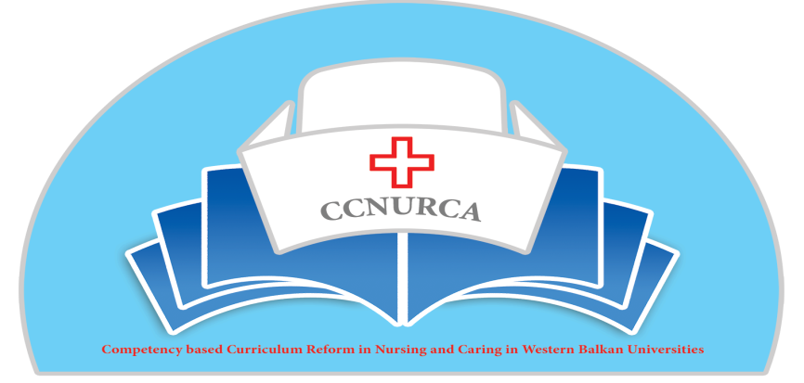

Activity: Seminar Nursing practical skills

Foca, 16 Maj, 2016

In Foca on 16 Maj 2016. was organized seminar «Practical nursing skills» in the frame of the Tempus project CCNURCA. The seminar was attended by 25 participants from partner institutions (Zenica, Mostar, Podgorica na East Sarajevo-Foca) in the project.
The seminar was opened by hosting institution. On behalf of host institution Mr Bokonjic welcomed all participants; briefly described agenda of the meeting; emphasized importance of the project for reform of the nursing education. Prof. Bokonjic also asked participants to take active role during the meeting and specially during group work. Some small changes in agenda were proposed. The agenda was adopted and accepted by all participants.

The main topics of the training were:
- Problem based learning,
- OSCE
- Computer based learning
- Payton methodology
- Debriefing
- Mind mapping

Training began with presentation of Prof Racic who briefly explained PBL during plenary seesion. After this she devided participants into small groups and distributed PBL case. All groups had tasks to discuss about case and solve part of the case. In the end during reflections all participants discuss the case and also place of this methodology inside nuring curriulum. All partiicpants agreed that there is a place for this teaching approach specially in the third and fourth year of studies.

Next presentation was given by prof Bokonjic who spoke about computer based studies. During plenary session he described role of virtual patients in everyday practice, advantages and disadvatages of this approach. After plenary session participants were taken to computer center were software Campus for virtual teaching were presented and demonstrated. All participants agreed that methodology is very attractive and useful but very demanding for teachers.

Next methodologies presented during seminar were Payton methodology and OSCE stations. Mrs Hadzivukovic, Pavlovic and Jokovic gave short presentations about teaching and assessment methodologies and divided participants into small groups. All participants were taken to clinical skill labs, divided into small groups and through some practical skills both methodologies were demonstrated to them.

Next speaker was Mr Oruc who presented debriefing as very important methodology for developing communication and team building skills. Debriefing is an important part of team building activities and allows students to process and reflect on their experience. The learning that occurs in these activities have "real world" applications and a quality debrief is one way to make that connection. The debrief should be facilitated by the instructor, with students taking control of their learning and leading the discussions. After plenary participants has an opportunity to see practical application of the methodology through role play perfectly organized by Zenica and Foca team.

Finally in the end Mrs Jokovic described mind-mapping as methodology. After plenary session all participants were divided into groups. Methodology was deconstructed and participants had the opportunity to see practical implementation and importance of this methodology.
In the end of this one day training all participants evaluated seminar.

Prof Bokonjic and Racic made final conclusions in the end seminar. Speakers and participants were certificated. All participants agreed to organize similar event for dissemination purposes on their institutions. Organizers of the seminar offered their help for organization of similar event on other institutions.

The meeting was perfectly organized by University of East Sarajevo, Faculty of Medicine and Mrs Racic and Mr Bokonjic and their team.

Project coordinator Maj, 2016.

