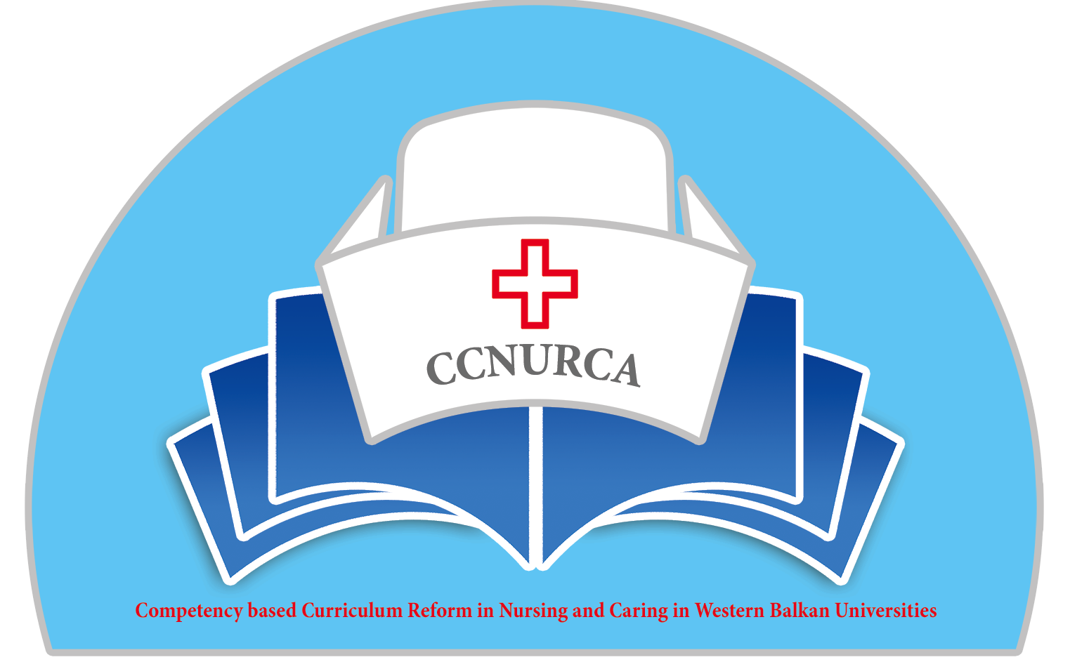

Agenda

Training-CCNURCA project
Setting up learning outcomes for new curriculum
Zenica, 04-07.06.2014

Venue: University of Zenica

Wednesday, 04 June 2014

Arrival of participants

Thursday, 05 June 2014

09.00 Welcome

Welcome and presentation of agenda
Mr. Mirza Oruc, UNZE
Mr. Dejan Bokonjic, University of East Sarajevo
Mr. Filip Dumez, HUB KAHO

09.30-09.50 Presentation of Competences-draft proposal of
competences for the new curriculum-Bokonjic Dejan

09.50-10.20 Learning outcomes for the new curriculum -Mirza Oruc

10.20-11.00 Coffee break

11.00-11.30 Competence based curriculum objectives-Filip Dumez

11.30-12.00 Teaching methodologies for new curriculum-
Johan van Wieren

12.00-12.30 Examining methodologies for new curriculum
Lubica Rybarova

Moderators: Srdjan Masic and Mirza Oruc

12.45-13.30 Lunch break

13.30-14.00 Project road map/Filip Dumez

14.00-14.30 Checking learning outcomes: level and the outcome-
delivery-assessment relationship-Ardian Cerava

14.30-15.00 Module qualification templates-matrix of
competences-Bokonjic Dejan

15.00-17.00 Group work-7 groups plus one mentor/developing of
new curriculum (main principles, different stages of
curriculum development, instructions for homework)

17.30-18.00 Conclusion of the day and technical issues
Willem vanden Berg

Moderators: Ardain Cerava and Dejan Boknojic

20.00 Dinner

Friday, 06 June 2014

09.30-11.30 Group work-5-7 groups plus one mentor/developing of
new curriculum (main principles, different stages of
curriculum development, instructions for homework)

11.30-11.50 Conclusion of the work and group presentations

11.50-12.10 Procurement of the equipment/ Srdjan Masic

12.10-12.30 Coffee break

12.30-12.50 Definition of new teaching materials (guideline for CBT
in nursing, catalogue of knowledge and skills/-

12.50-13.10 Dissemination activities
Willem vanden Berg and Dejan Bokonjic

13.10-13.30 Future activities, deadlines, dividing of responsibilities and obligations among the partners
Conclusions and closing of the training
Filip Dumez and Dejan Bokonjic

13.30-14.00 Lunch break

Saturday, 07 June 2014

Departure of participants

List of mentors for group work>

Filip Dumez
Dejan Bokonjic
Lubica Rybarova
Johan van Wieren
Mirza Oruc

