Descriptive-general
Total number of participants: 25 | N of questionnaires | Minimum mark | Maximum mark | Mean mark
How do you estimate your motivation during session? | 75 | 2 | 5 | 4,47
How do you estimate support of tutor duirng session? | 75 | 2 | 5 | 4,59
What do you think about motivation of the tutor? | 75 | 2 | 5 | 4,65
Do you have possibility to ask question to tutor during session? | 75 | 2 | 5 | 4,64
Did you get satisfactory answers duirng sssion? | 75 | 2 | 5 | 4,61
How do you estimate your understanding of methodology you are studying during session? | 75 | 2 | 5 | 4,45
Presented methodology will help me in future teaching process. | 75 | 1 | 5 | 4,51
How do you estimate working atmosphere in the group? | 75 | 2 | 5 | 4,51
Whta average mark you will give to other colleagues in the group? | 75 | 2 | 5 | 4,57
How do you estimate content of the course and session? | 75 | 2 | 5 | 4,65
How do you estimate your knowledge after session? | 75 | 2 | 5 | 4,57
How do you estimate your skills after session? | 75 | 2 | 5 | 4,43
How do you estimate your independent work during session? | 75 | 2 | 5 | 4,45
How do you estimate organization of seminat until now? | 75 | 2 | 5 | 4,67

Charts

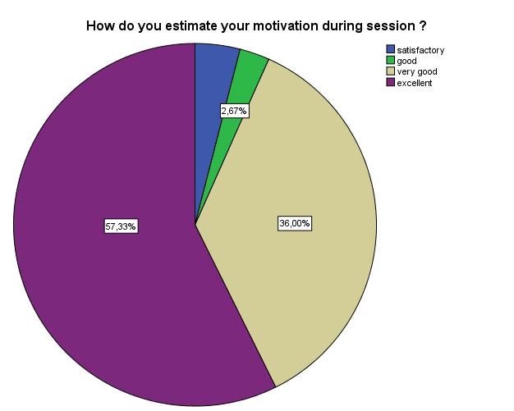

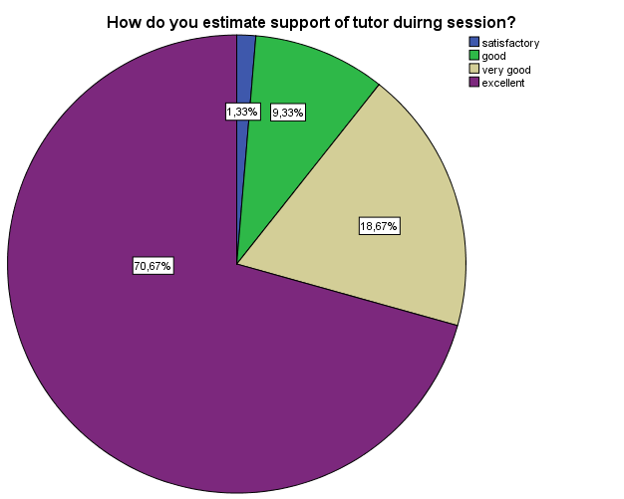

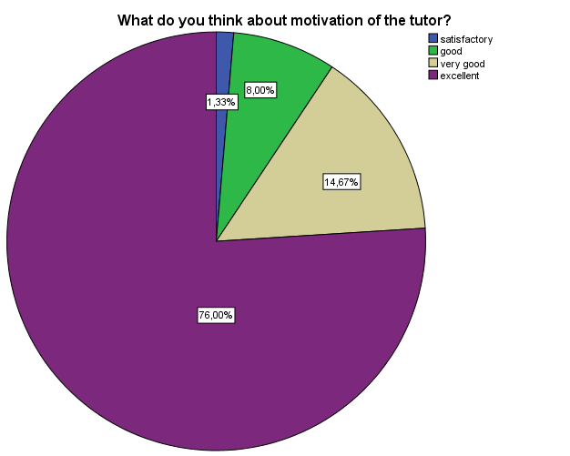

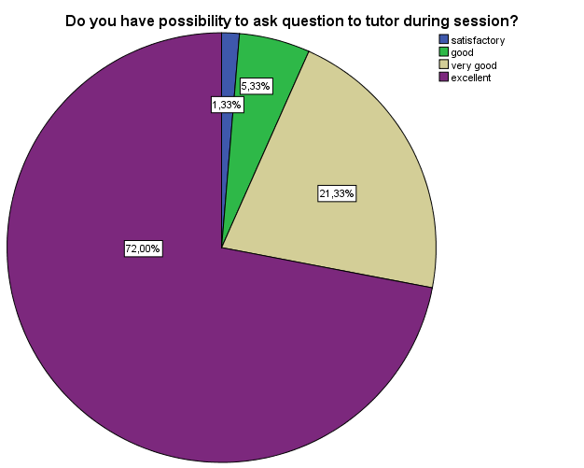

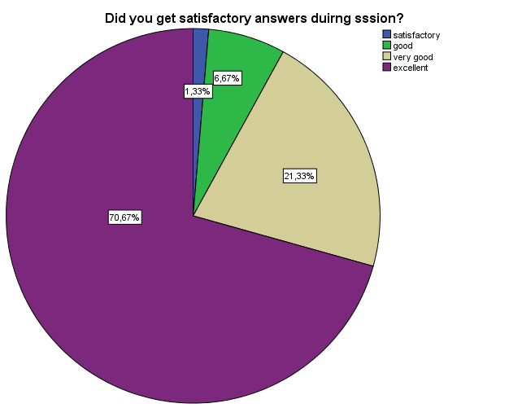

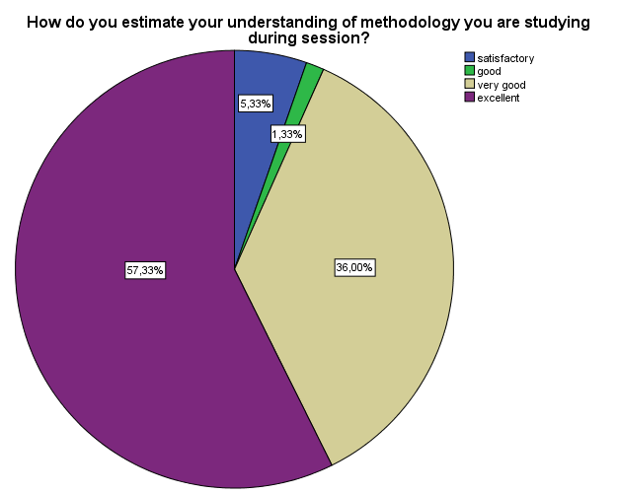

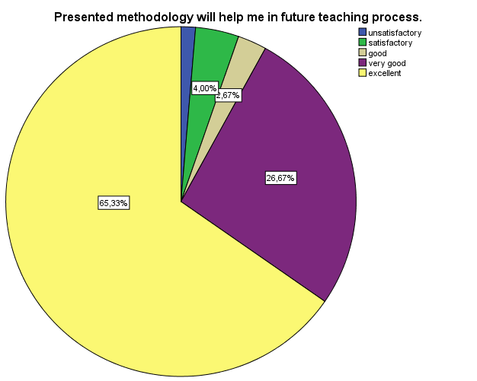

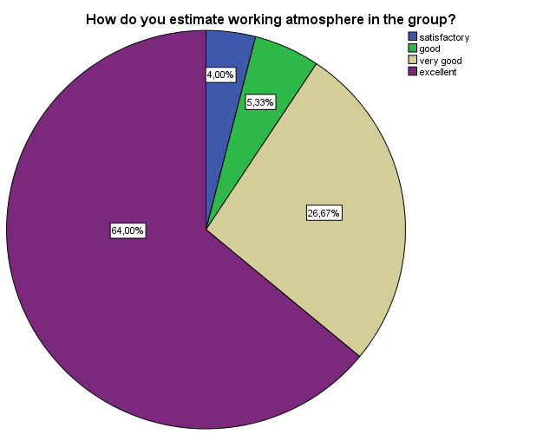

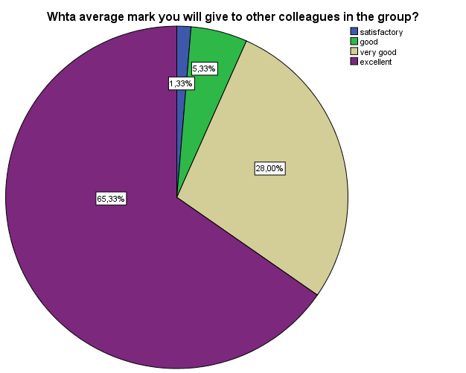

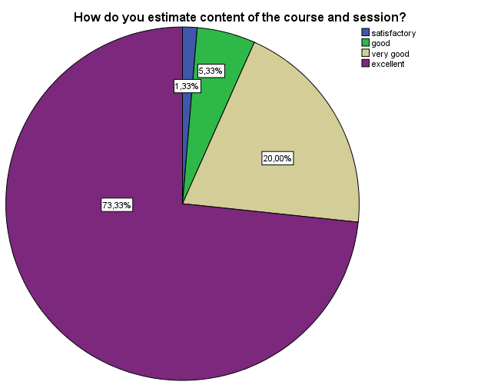

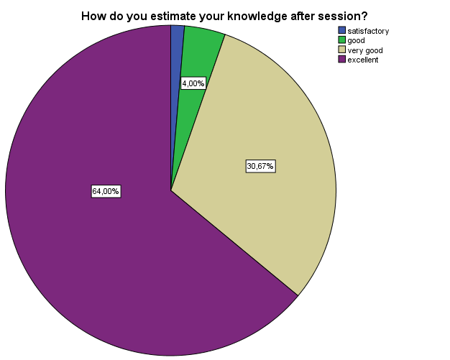

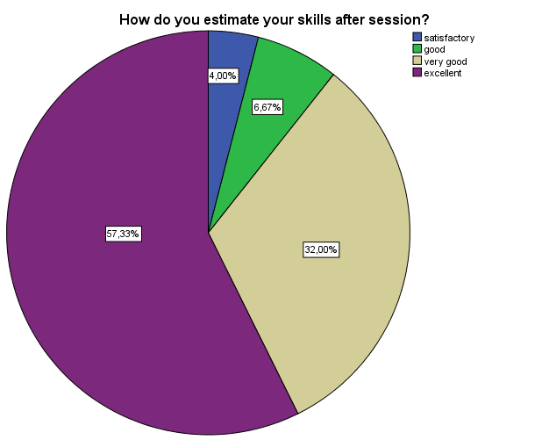

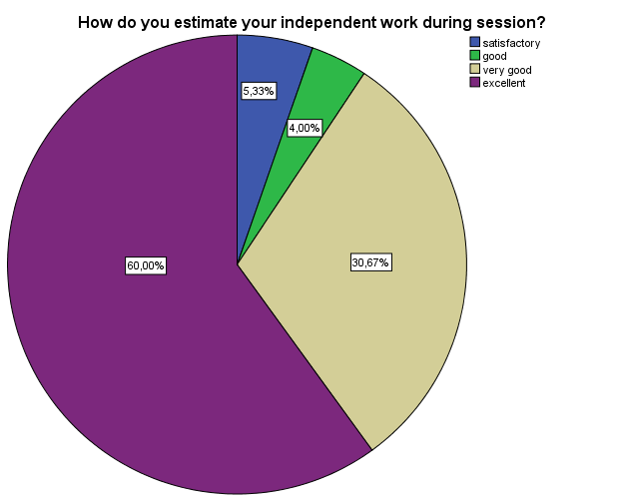

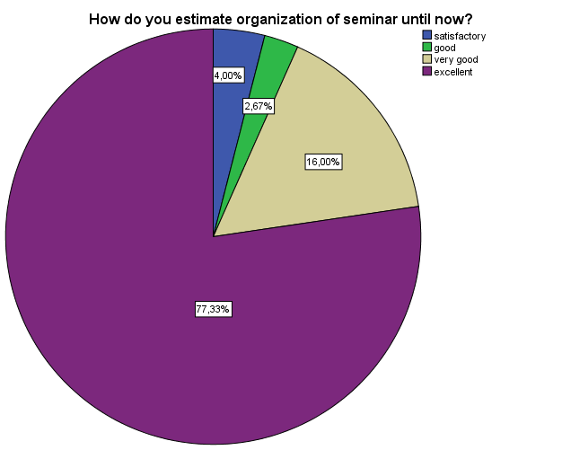

Statistics: According to working (training) days

Training day * How do you estimate your motivation during session ?
 |  |  | How do you estimate your motivation during session ?
 |  |  | satisfactory | good | very good | excellent
Training day | 1st | Count | 3 | 1 | 9 | 12
 |  | % within Training day | 12,0% | 4,0% | 36,0% | 48,0%
 | 2nd | Count | 0 | 0 | 7 | 18
 |  | % within Training day | 0,0% | 0,0% | 28,0% | 72,0%
 | 3rd | Count | 0 | 1 | 11 | 13
 |  | % within Training day | 0,0% | 4,0% | 44,0% | 52,0%
Total |  | Count | 3 | 2 | 27 | 43
 |  | % within Training day | 4,0% | 2,7% | 36,0% | 57,3%

Training day * How do you estimate your motivation during session ?
 |  |  | Total
Training day | 1st | Count | 25
 |  | % within Training day | 100,0%
 | 2nd | Count | 25
 |  | % within Training day | 100,0%
 | 3rd | Count | 25
 |  | % within Training day | 100,0%
Total |  | Count | 75
 |  | % within Training day | 100,0%

Training day * How do you estimate support of tutor duirng session?
 |  |  | How do you estimate support of tutor duirng session?
 |  |  | satisfactory | good | very good | excellent
Training day | 1st | Count | 1 | 4 | 3 | 17
 |  | % within Training day | 4,0% | 16,0% | 12,0% | 68,0%
 | 2nd | Count | 0 | 0 | 2 | 23
 |  | % within Training day | 0,0% | 0,0% | 8,0% | 92,0%
 | 3rd | Count | 0 | 3 | 9 | 13
 |  | % within Training day | 0,0% | 12,0% | 36,0% | 52,0%
Total |  | Count | 1 | 7 | 14 | 53
 |  | % within Training day | 1,3% | 9,3% | 18,7% | 70,7%

Training day * How do you estimate support of tutor duirng session?
 |  |  | Total
Training day | 1st | Count | 25
 |  | % within Training day | 100,0%
 | 2nd | Count | 25
 |  | % within Training day | 100,0%
 | 3rd | Count | 25
 |  | % within Training day | 100,0%
Total |  | Count | 75
 |  | % within Training day | 100,0%

Training day * What do you think about motivation of the tutor?
 |  |  | What do you think about motivation of the tutor?
 |  |  | satisfactory | good | very good | excellent
Training day | 1st | Count | 1 | 3 | 3 | 18
 |  | % within Training day | 4,0% | 12,0% | 12,0% | 72,0%
 | 2nd | Count | 0 | 1 | 1 | 23
 |  | % within Training day | 0,0% | 4,0% | 4,0% | 92,0%
 | 3rd | Count | 0 | 2 | 7 | 16
 |  | % within Training day | 0,0% | 8,0% | 28,0% | 64,0%
Total |  | Count | 1 | 6 | 11 | 57
 |  | % within Training day | 1,3% | 8,0% | 14,7% | 76,0%

Training day * What do you think about motivation of the tutor?
 |  |  | Total
Training day | 1st | Count | 25
 |  | % within Training day | 100,0%
 | 2nd | Count | 25
 |  | % within Training day | 100,0%
 | 3rd | Count | 25
 |  | % within Training day | 100,0%
Total |  | Count | 75
 |  | % within Training day | 100,0%

Training day * Do you have possibility to ask question to tutor during session?
 |  |  | Do you have possibility to ask question to tutor during session?
 |  |  | satisfactory | good | very good | excellent
Training day | 1st | Count | 1 | 2 | 5 | 17
 |  | % within Training day | 4,0% | 8,0% | 20,0% | 68,0%
 | 2nd | Count | 0 | 0 | 2 | 23
 |  | % within Training day | 0,0% | 0,0% | 8,0% | 92,0%
 | 3rd | Count | 0 | 2 | 9 | 14
 |  | % within Training day | 0,0% | 8,0% | 36,0% | 56,0%
Total |  | Count | 1 | 4 | 16 | 54
 |  | % within Training day | 1,3% | 5,3% | 21,3% | 72,0%

Training day * Do you have possibility to ask question to tutor during session?
 |  |  | Total
Training day | 1st | Count | 25
 |  | % within Training day | 100,0%
 | 2nd | Count | 25
 |  | % within Training day | 100,0%
 | 3rd | Count | 25
 |  | % within Training day | 100,0%
Total |  | Count | 75
 |  | % within Training day | 100,0%

Training day * Did you get satisfactory answers duirng sssion?
 |  |  | Did you get satisfactory answers duirng sssion?
 |  |  | satisfactory | good | very good | excellent
Training day | 1st | Count | 1 | 2 | 4 | 18
 |  | % within Training day | 4,0% | 8,0% | 16,0% | 72,0%
 | 2nd | Count | 0 | 1 | 5 | 19
 |  | % within Training day | 0,0% | 4,0% | 20,0% | 76,0%
 | 3rd | Count | 0 | 2 | 7 | 16
 |  | % within Training day | 0,0% | 8,0% | 28,0% | 64,0%
Total |  | Count | 1 | 5 | 16 | 53
 |  | % within Training day | 1,3% | 6,7% | 21,3% | 70,7%

Training day * Did you get satisfactory answers duirng sssion?
 |  |  | Total
Training day | 1st | Count | 25
 |  | % within Training day | 100,0%
 | 2nd | Count | 25
 |  | % within Training day | 100,0%
 | 3rd | Count | 25
 |  | % within Training day | 100,0%
Total |  | Count | 75
 |  | % within Training day | 100,0%

Training day * How do you estimate your understanding of methodology you are studying during session?
 |  |  | How do you estimate your understanding of methodology you are studying during session?
 |  |  | satisfactory | good | very good | excellent
Training day | 1st | Count | 4 | 0 | 11 | 10
 |  | % within Training day | 16,0% | 0,0% | 44,0% | 40,0%
 | 2nd | Count | 0 | 0 | 6 | 19
 |  | % within Training day | 0,0% | 0,0% | 24,0% | 76,0%
 | 3rd | Count | 0 | 1 | 10 | 14
 |  | % within Training day | 0,0% | 4,0% | 40,0% | 56,0%
Total |  | Count | 4 | 1 | 27 | 43
 |  | % within Training day | 5,3% | 1,3% | 36,0% | 57,3%

Training day * How do you estimate your understanding of methodology you are studying during session?
 |  |  | Total
Training day | 1st | Count | 25
 |  | % within Training day | 100,0%
 | 2nd | Count | 25
 |  | % within Training day | 100,0%
 | 3rd | Count | 25
 |  | % within Training day | 100,0%
Total |  | Count | 75
 |  | % within Training day | 100,0%

Training day * Presented methodology will help me in future teaching process.
 |  |  | Presented methodology will help me in future teaching process.
 |  |  | unsatisfactory | satisfactory | good | very good | excellent
Training day | 1st | Count | 1 | 3 | 1 | 4 | 16
 |  | % within Training day | 4,0% | 12,0% | 4,0% | 16,0% | 64,0%
 | 2nd | Count | 0 | 0 | 1 | 2 | 22
 |  | % within Training day | 0,0% | 0,0% | 4,0% | 8,0% | 88,0%
 | 3rd | Count | 0 | 0 | 0 | 14 | 11
 |  | % within Training day | 0,0% | 0,0% | 0,0% | 56,0% | 44,0%
Total |  | Count | 1 | 3 | 2 | 20 | 49
 |  | % within Training day | 1,3% | 4,0% | 2,7% | 26,7% | 65,3%

Training day * Presented methodology will help me in future teaching process.
 |  |  | Total
Training day | 1st | Count | 25
 |  | % within Training day | 100,0%
 | 2nd | Count | 25
 |  | % within Training day | 100,0%
 | 3rd | Count | 25
 |  | % within Training day | 100,0%
Total |  | Count | 75
 |  | % within Training day | 100,0%

Training day * How do you estimate working atmosphere in the group?
 |  |  | How do you estimate working atmosphere in the group?
 |  |  | satisfactory | good | very good | excellent
Training day | 1st | Count | 3 | 1 | 9 | 12
 |  | % within Training day | 12,0% | 4,0% | 36,0% | 48,0%
 | 2nd | Count | 0 | 0 | 5 | 20
 |  | % within Training day | 0,0% | 0,0% | 20,0% | 80,0%
 | 3rd | Count | 0 | 3 | 6 | 16
 |  | % within Training day | 0,0% | 12,0% | 24,0% | 64,0%
Total |  | Count | 3 | 4 | 20 | 48
 |  | % within Training day | 4,0% | 5,3% | 26,7% | 64,0%

Training day * How do you estimate working atmosphere in the group?
 |  |  | Total
Training day | 1st | Count | 25
 |  | % within Training day | 100,0%
 | 2nd | Count | 25
 |  | % within Training day | 100,0%
 | 3rd | Count | 25
 |  | % within Training day | 100,0%
Total |  | Count | 75
 |  | % within Training day | 100,0%

Training day * Whot average mark you will give to other colleagues in the group?
 |  |  | Whot average mark you will give to other colleagues in the group?
 |  |  | satisfactory | good | very good | excellent
Training day | 1st | Count | 1 | 2 | 6 | 16
 |  | % within Training day | 4,0% | 8,0% | 24,0% | 64,0%
 | 2nd | Count | 0 | 0 | 4 | 21
 |  | % within Training day | 0,0% | 0,0% | 16,0% | 84,0%
 | 3rd | Count | 0 | 2 | 11 | 12
 |  | % within Training day | 0,0% | 8,0% | 44,0% | 48,0%
Total |  | Count | 1 | 4 | 21 | 49
 |  | % within Training day | 1,3% | 5,3% | 28,0% | 65,3%

Training day * Whot average mark you will give to other colleagues in the group?
 |  |  | Total
Training day | 1st | Count | 25
 |  | % within Training day | 100,0%
 | 2nd | Count | 25
 |  | % within Training day | 100,0%
 | 3rd | Count | 25
 |  | % within Training day | 100,0%
Total |  | Count | 75
 |  | % within Training day | 100,0%

Training day * How do you estimate content of the course and session?
 |  |  | How do you estimate content of the course and session?
 |  |  | satisfactory | good | very good | excellent
Training day | 1st | Count | 1 | 3 | 4 | 17
 |  | % within Training day | 4,0% | 12,0% | 16,0% | 68,0%
 | 2nd | Count | 0 | 0 | 2 | 23
 |  | % within Training day | 0,0% | 0,0% | 8,0% | 92,0%
 | 3rd | Count | 0 | 1 | 9 | 15
 |  | % within Training day | 0,0% | 4,0% | 36,0% | 60,0%
Total |  | Count | 1 | 4 | 15 | 55
 |  | % within Training day | 1,3% | 5,3% | 20,0% | 73,3%

Training day * How do you estimate content of the course and session?
 |  |  | Total
Training day | 1st | Count | 25
 |  | % within Training day | 100,0%
 | 2nd | Count | 25
 |  | % within Training day | 100,0%
 | 3rd | Count | 25
 |  | % within Training day | 100,0%
Total |  | Count | 75
 |  | % within Training day | 100,0%

Training day * How do you estimate your knowledge after session?
 |  |  | How do you estimate your knowledge after session?
 |  |  | satisfactory | good | very good | excellent
Training day | 1st | Count | 1 | 2 | 6 | 16
 |  | % within Training day | 4,0% | 8,0% | 24,0% | 64,0%
 | 2nd | Count | 0 | 0 | 6 | 19
 |  | % within Training day | 0,0% | 0,0% | 24,0% | 76,0%
 | 3rd | Count | 0 | 1 | 11 | 13
 |  | % within Training day | 0,0% | 4,0% | 44,0% | 52,0%
Total |  | Count | 1 | 3 | 23 | 48
 |  | % within Training day | 1,3% | 4,0% | 30,7% | 64,0%

Training day * How do you estimate your knowledge after session?
 |  |  | Total
Training day | 1st | Count | 25
 |  | % within Training day | 100,0%
 | 2nd | Count | 25
 |  | % within Training day | 100,0%
 | 3rd | Count | 25
 |  | % within Training day | 100,0%
Total |  | Count | 75
 |  | % within Training day | 100,0%

Training day * How do you estimate your skills after session?
 |  |  | How do you estimate your skills after session?
 |  |  | satisfactory | good | very good | excellent
Training day | 1st | Count | 3 | 1 | 6 | 15
 |  | % within Training day | 12,0% | 4,0% | 24,0% | 60,0%
 | 2nd | Count | 0 | 0 | 8 | 17
 |  | % within Training day | 0,0% | 0,0% | 32,0% | 68,0%
 | 3rd | Count | 0 | 4 | 10 | 11
 |  | % within Training day | 0,0% | 16,0% | 40,0% | 44,0%
Total |  | Count | 3 | 5 | 24 | 43
 |  | % within Training day | 4,0% | 6,7% | 32,0% | 57,3%

Training day * How do you estimate your skills after session?
 |  |  | Total
Training day | 1st | Count | 25
 |  | % within Training day | 100,0%
 | 2nd | Count | 25
 |  | % within Training day | 100,0%
 | 3rd | Count | 25
 |  | % within Training day | 100,0%
Total |  | Count | 75
 |  | % within Training day | 100,0%

Training day * How do you estimate your independent work during session?
 |  |  | How do you estimate your independent work during session?
 |  |  | satisfactory | good | very good | excellent
Training day | 1st | Count | 4 | 1 | 7 | 13
 |  | % within Training day | 16,0% | 4,0% | 28,0% | 52,0%
 | 2nd | Count | 0 | 0 | 7 | 18
 |  | % within Training day | 0,0% | 0,0% | 28,0% | 72,0%
 | 3rd | Count | 0 | 2 | 9 | 14
 |  | % within Training day | 0,0% | 8,0% | 36,0% | 56,0%
Total |  | Count | 4 | 3 | 23 | 45
 |  | % within Training day | 5,3% | 4,0% | 30,7% | 60,0%

Training day * How do you estimate your independent work during session?
 |  |  | Total
Training day | 1st | Count | 25
 |  | % within Training day | 100,0%
 | 2nd | Count | 25
 |  | % within Training day | 100,0%
 | 3rd | Count | 25
 |  | % within Training day | 100,0%
Total |  | Count | 75
 |  | % within Training day | 100,0%

Training day * How do you estimate organization of seminar until now?
 |  |  | How do you estimate organization of seminar until now?
 |  |  | satisfactory | good | very good | excellent
Training day | 1st | Count | 3 | 1 | 4 | 17
 |  | % within Training day | 12,0% | 4,0% | 16,0% | 68,0%
 | 2nd | Count | 0 | 0 | 3 | 22
 |  | % within Training day | 0,0% | 0,0% | 12,0% | 88,0%
 | 3rd | Count | 0 | 1 | 5 | 19
 |  | % within Training day | 0,0% | 4,0% | 20,0% | 76,0%
Total |  | Count | 3 | 2 | 12 | 58
 |  | % within Training day | 4,0% | 2,7% | 16,0% | 77,3%

Training day * How do you estimate organization of seminar until now?
 |  |  | Total
Training day | 1st | Count | 25
 |  | % within Training day | 100,0%
 | 2nd | Count | 25
 |  | % within Training day | 100,0%
 | 3rd | Count | 25
 |  | % within Training day | 100,0%
Total |  | Count | 75
 |  | % within Training day | 100,0%

