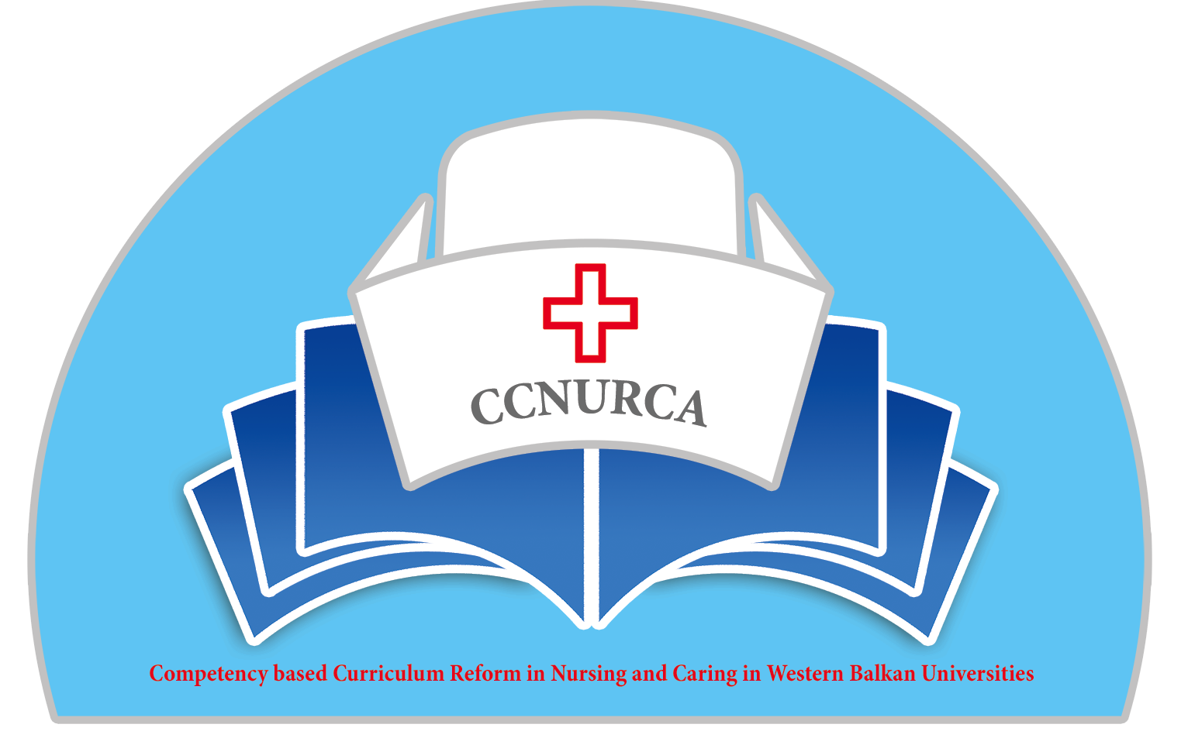

Agenda

Steering committee meeting
CCNURCA project
University of Zenica, 17.11.2015

Venue: University of Zenica

Monday and Tuesday, 16 and 17 November 2015

Arrival of participants

Tuesday, 17 November 2015

16.00 – 16.20 Welcome speech
Mirza Oruc, Dejan Bokonjic, Filip Dumez

16.20 – 16.50 Overview of activities for the 1st and second project year/planned versus implemented activities
Filip Dumez

16.50 – 17.10 Overview of financial situation
Dejan Bokonjic,

17.10-17.30 Dissemination and sustainability/
Mirza Oruc and Srdjan Masic

17.30 - 18.15 Brief overview of partner institutions/main results

18.15 18.30 Future plans/plan for activities in the 3rd project year
Filip Dumez, Dejan Bokonjic, Mirza Oruc

18.30 - 18.45 Plan for monitoring of BH nursing schools and Nursing school
University of Montenegro
Andre Govaert

18.45 – 19.00 Conclusions, divisions of responsibilities
Dejan Bokonjic

