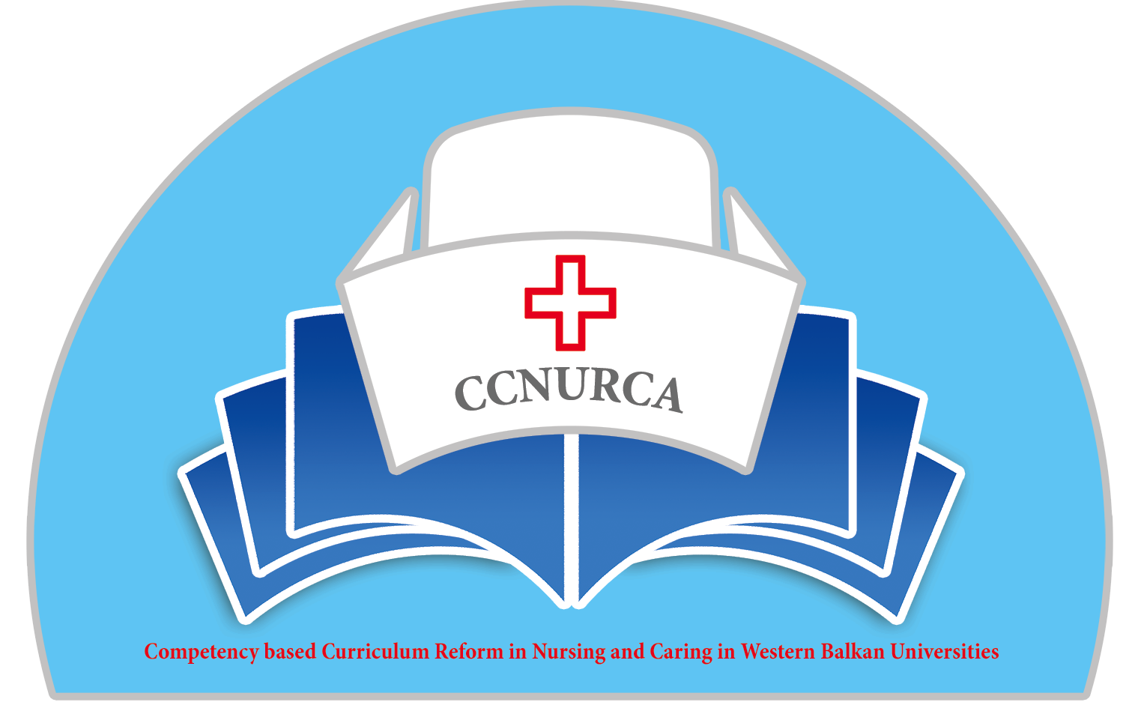

Agenda

Training and consortium meeting
CCNURCA project
University of East Sarajevo, Foca

Venue: University of East Sarajevo

Wednesday, 01 June 2016

Arrival of participants from WB countries and EU countries

Thursday, 02 June 2016

09.00-09.20 Welcome to the consortium meeting
Willem vanden Berg, Bokonjic Dejan

09.20-10.00 Overview of performed activities. Srdjan Masic

10.00-10.30 Overview of financial situation
Willem vanden Berg

10.30-11.30 Presentation of the results of the pilot project
(Each WB partner institution 10 minutes)
University of Zenica
University of Montenegro
University of Korca
University of Shkodra
University of Gjirokastra
University of Mostar
University of East Sarajevo

11.30 Coffee break

12.00-12.15 Dissemination activities plan until end of the project
Mirza Oruc

12.15-12.30 Presentation of the qualification framework in BH in the field of Medical sciences
Dejan Bokonjic

Discussion

12.30 Lunch

13.30-15.15 Preparation of self-assessment report
Progress by each University until now
(Each WB partner institution 15-20 minutes)
University of Zenica
University of Montenegro
University of Korca
University of Shkodra
University of Gjirokastra
University of Mostar
University of East Sarajevo

15.15-15.45 Comments on catalogue of knowledge and skills by EU partners
All EU partners

15.45-16.00 Draft proposal for the structure of the newsletter
Srdjan Masic

16.00-16.15 Coffee break

16.15-16.30 Final draft catalogue knowledge and skills
Mirza Oruc

16.30-17.00 Sustainability plan for each partner institution
(Each WB partner institution 5 minutes)

University of Zenica
University of Montenegro
University of Korca
University of Shkodra
University of Gjirokastra
University of Mostar
Universty of East Sarajevo

17.00-17.15 The development (Drupal) and the usefulness of the project site.
Mr Carlo Van den Bunder (Odisee, ICT Developer)

17.15-17.30 Financial plan, collecting of missing documents and also prolongation plan
Willem vanden Berg

17.30-17.45 Conclusions, divisions of responsibilities, discussion about new projects
Dejan Bokonjic,

19.30 Dinner

Friday, 03 June 2016

09.00 Teaching activities/presentations of EU partners for the students. Three presentation from three different EU institutions (20 minutes each). EU partners to propose actual nursing topic

10.00 Presentation of the project to teaching staff Medical faculty Foca

11.00 Visitation to training facilities Medical faculty Foca

12.00 Clinical skills lab/working in small groups

13:00 lunch

Sightseeing tour/rafting on river Tara or visit to lakes on the Mountain Zelengora

Saturday, 04 June 2016

Departure of the participants

