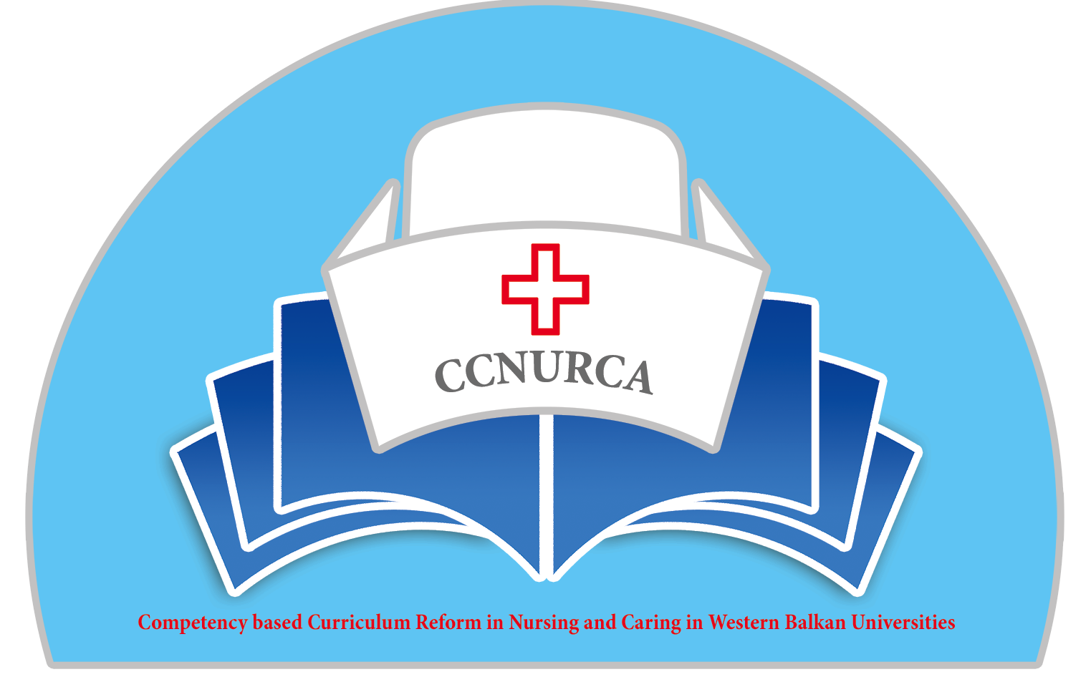

Agenda

CCNURCA project
Train The Trainer session: knowledge exchange between EU and WB partners
Mostar, 20.02.17-22.02.2017

Monday, 20 February 2017

Arrival of participants in Mostar

Tuesday, 21 February 2017

09.00 Registration and coffee

09.15 Welcome and presentation of the agenda

09.20 How to monitoring the implementation of a new nursing curriculum?
What are the pitfalls and the necessary tools?
K. Gillis

10.20 Internship? How to evaluate on an objective way?
B. Drieghe

11.20 Coffee break

11.30 How to incorporate debriefing, the use of video’s in our new curriculum?
Simulation in Health care education
T. Torsy

12.30 Lunch

14.00 Workshop 1: Quality of assessment
K. Gillis

14.00 Workshop 2: Coaching of students or mentors
M. Michiels - M. Goedemé

15.30 Coffee break

15.45 Workshop 1: Quality of assessment
K. Gillis

15.45 Workshop 2: Coaching of students or mentors
M. Michiels - M. Goedemé

17.15 Concluding remarks
Dejan Bokonjic & Mirza Oruc

19.00 Dinner

Wednesday, 22 February 2017

Departure of participants

