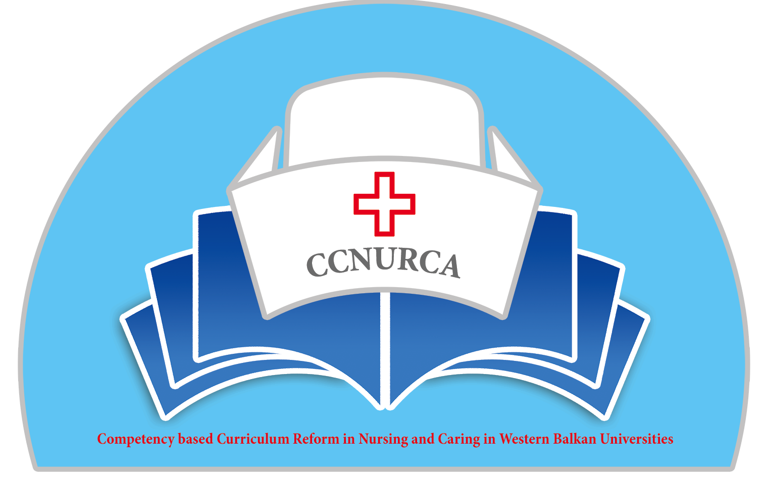

Agenda

Training-CCNURCA project
Practical training in nursing; knowledge exchange between EU and WB partners
Sint Niklaas, 13.10-15.10.2014

Venue:

HUB – KAHO; Campus Waas (Hospitaalstraat 23, Sint Niklaas)

The venue is about 15 min. walking from the station of Sint Niklaas.
http://www.hubkaho.be/HUB_KAHO/HUBKAHO/(9038)-HUB-KAHO-Bestanden/(9038)-HUB-KAHO-Bestanden-Studentenvoorzieningen/Plan-bereikbaarheid-Sint-Niklaas.pdf

Sunday, 12 October 2014

Arrival of participants in Sint Niklaas.

Monday, 13 October 2014

09.00 Registration and coffee

09.20 Welcome and presentation of the agenda
Candice De Windt; Dejan Bokonjic

09.30 Presentation of the campus
Katrin Gilis

09.45 Visit to the campus and the skills lab

10.15 Organization of the skills lab
Kate De Winter

10.45 Coffee break

11.00 Engaging students in practical training
Belinda Drieghe, Dorien De Meyer

12.00 Lunch

13.00 Preparation of practical training
Belinda Drieghe, Dorien De Meyer

13.30 Observation of live practical training with students
Belinda Drieghe, Dorien De Meyer

14.30 Reflection on practical training
Belinda Drieghe, Dorien De Meyer

15.00 Coffee break

15.15 Assessing practical skills: intermediate and final
Belinda Drieghe, Dorien De Meyer

17.00 Concluding remarks
Dejan Bokonjic, Filip Dumez

19.00 Dinner

Tuesday, 14 October 2014

09.00 Registration and coffee

09.20 Explanation of the day program
Belinda Drieghe, Dorien De Meyer

09.30 Demonstration of practical skills training
Belinda Drieghe, Dorien De Meyer

10.15 Testing, evaluation and feedback
Belinda Drieghe, Dorien De Meyer

11.00 Coffee break

11.15 Preparing a practical skills training and assessment
WB members

12.00 Lunch

13.00 Demonstration of practical skills training and assessment
WB members

14.00 Reflection on practical skills training and assessment
All participants

14.45 Coffee break

15.00 Management of practical competence- training for nursing students
Belinda Drieghe, Dorien De Meyer

16.00 Peer coaching
Belinda Drieghe, Dorien De Meyer

17.00 Concluding remarks
Dejan Bokonjic, Filip Dumez

Moderators : Michel Van Dijck, Mirza Oruc

19.00 Dinner

Wednesday, 15 October 2014

08.30 Registration and coffee

09.00 Organization of internships
Belinda Drieghe, Dorien De Meyer

10.00 Workplace training and workplace learning
Belinda Drieghe, Dorien De Meyer

11.00 Financial and technical issues
Willem Vanden Berg

12.00 Concluding remarks and future appointments
Dejan Bokonjic, Filip Dumez

12.30 Lunch

13.00 Social program (optional)

Departure of participants

