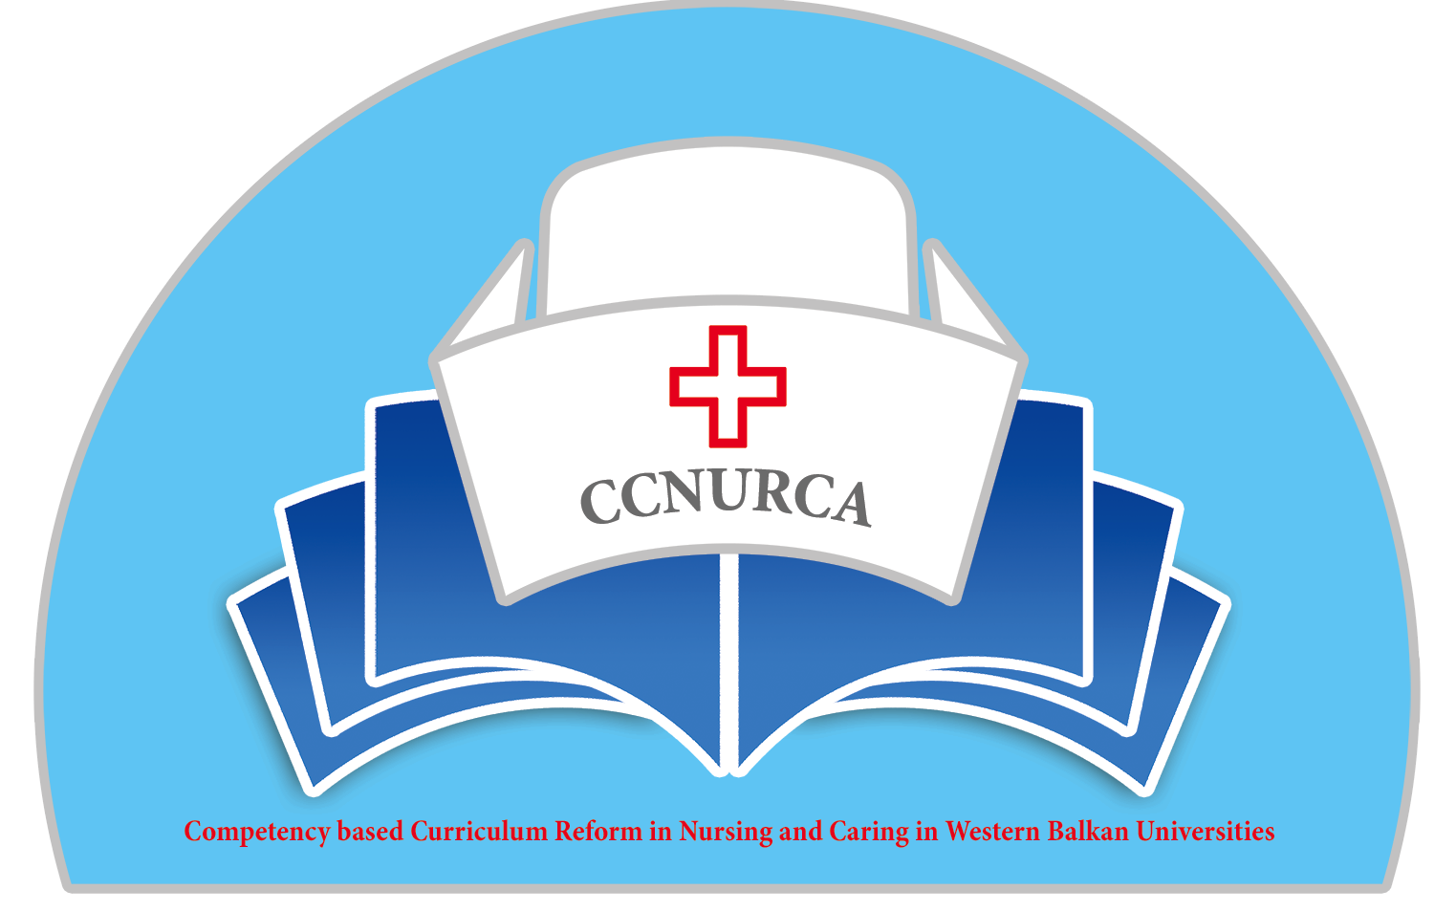

Agenda

Meeting
CCNURCA project
University of Presov, 8-12.02.2015

Venue: University of Presov, Faculty of nursing

Sunday, 8 February, 2015

Arrival of participants

Monday, 9 February, 2015

09.00 Welcome
Lubica Rybarova
Filip Dumez
Dejan Bokonjic

09.15. Presentation of University of Presov, faculty of nursing and nursing curricula/ Lubica Rybarova

Consortium meeting

09.45-11.45 Presentation by partner universities What is achieved/what is changed/what should be done. Impressions and satisfactions about whole project

09.45-10.00 Presentation of activities done so far in CCNURCA –main benefits University of-Zenica/ Mr Mirza Oruc

10.00 -10.15 Presentation of activities done so far in CCNURCA-
main benefits -University of Mostar

10.15-10-30 Presentation of activities done so far in CCNURCA-
main main benefits -University of Montenegro

10-30-10.45 Presentation of activities done so far in CCNURCA-
main benefits -University of Korca

10.45-11.00 Presentation of activities done so far in CCNURCA-
main benefits -University of East Sarajevo

11.00-11.15 Coffee break

11.15-11.30 Presentation of activities done so far in CCNURCA-
main benefits -University of Skhodra

11.30-11-45 Presentation of activities done so far in CCNURCA-
main benefits -University of Gjirocastra

Moderator: Srdjan Masic

11.45-12.15 Good points and points for improvement in CCNURCA project- opinion of EU experts (Ghent, Groningen and Presov)

12.15-12.45 Presentation of CCNURCA project-activities performed until now-Mirza Oruc

12.45-13.30 Lunch break

13.30-14.00 Management of the project and project workplan
Filip Dumez and Dejan Bokonjic

14.00-14.20 Purchasing of equipment and dissemination activities
Srdjan Masic

14.20-14.40 External evaluation of the project achievements-
Andre Govaert

14.40-15.00 Financial overview of the project-status of staff and travel costs-Willem vanden Berg

15.00-15.20 Discussion about acceptance of the new curricula and competence based approach-Representatives of Ministries and Universities from Partner countries- Dejan Bokonjic

15.20-15.40 Publishing activities. Current status and future plans
Mirza Oruc and Filip Dumez

15.40-16.00 Workplan-presentation of activities for the second and beginning of the third project year-Dejan Bokonjic

16.00-16.30 Deadlines and dividing of responsibilities and obligations among the partners
Filip Dumez and Dejan Bokonjic

16.30-17.00 Conclusion of the day and technical issues
Filip Dumez and Willem vanden Berg

Moderators: André Govaert and Willem vanden Berg

19.30 Official dinner

Tuesday, 10 February,2015.

09.30 Welcome

Welcome and presentation of agenda
Mrs. Filip Dumez, Odisee
Mr. Dejan Bokonjic, University of East Sarajevo

09.45-10.05. Presentation of tuning project in area of nursing /Zuzana Slezakova

10.05-10.30 Overview of teaching methodologies/Lubica Rybarova

10.30-11.00. Portfolio for internship/Kaaijk Maarten

11.00-11.30. Examination and assessment of practical period/Kaaijk Maarten

11.30-12.45. Sightseeing tour-University of Presov, faculty of nursing

Moderator: Mirza Oruc

12.45-14.00. Lunch break

14.00-16.30 Groupwork /3 groups
Group from BH (University of Mostar, University of East Sarajevo and University of Zenica)-Experts from Belgium
Group from Albania (University of Korca, University of Gjirocastra, University of Shodra) Experts from Netherlands
University of Monetenegro-Experts from Slovakia.
Each group should work on analyses of curricula, matrix of competences and sillabi of the courses

16.30-17.00. Presentation of the outputs of the day. representatives of each group 5-10 minutes

17.00-17.15 Conclusion of the day- Filip Dumez and Dejan Bokonjic

Moderator: Srdjan Masic

Dinner

Wednesday, 11 February 2015

09.00-11.30 Groupwork /3 groups –continuation from the first day

Group from BH (University of Mostar, University of East Sarajevo and University of Zenica)-Experts from Belgium
Group from Albania (University of Korca, University of Gjirocastra, University of Shodra) Experts from Netherlands
University of Monetenegro-Experts from Slovakia.

11.30-12.00 - Overview / curricula and one course /details/
/ Impressions and satisfactions-All partners and EU experts

12.00-12.20-Defining of clear tasks and deadlines concerning developing of curricula and introducing competences for partner Universities-Filip Dumez

12.20-12.30 Conclusion of training-Lubica Rybarova and Filip Dumez

13.00 Lunch

Sightseeing tour in the afternoon

Dinner

Thursday, 12. February,2015

Departure of participants

Project coordination team

