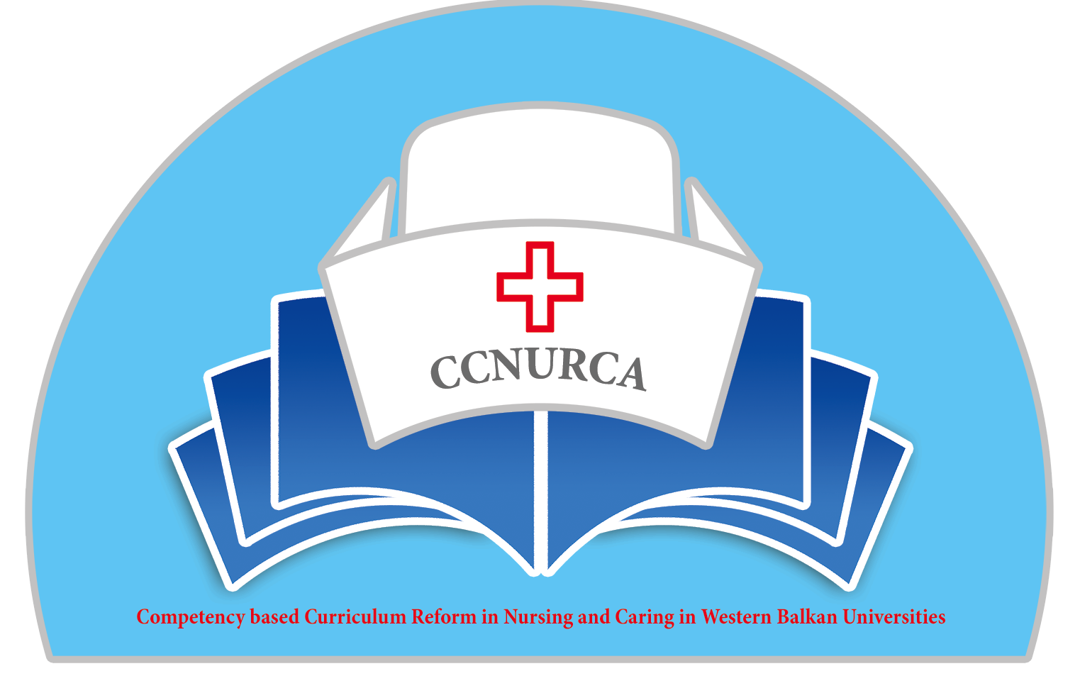

Agenda

Training-CCNURCA project
Comparative analysis of competences and nursing curriculum between EU and WB partners
Mostar, 07.04-10.04.2014

Venue: University of Mostar,

Monday, 07 April 2014

Arrival of participants

Tuesday, 08 April 2014

09.00 Welcome

Welcome and presentation of agenda
Mr. Mladen Mimica, UNMO
Mr. Dejan Bokonjic, University of East Sarajevo
Mr. Filip Dumez, HUB KAHO

09.30-09.50 Presentation of Groningen University-nursing
department and nursing curriculum/Kaaijk MM Marten,
Johan van Wieren

09.50-10.20 Analysis of nursing curriculum of the WB partner institutions-main characteristics-Mirza Oruc

10.20-11.00 Coffee break

11.00-11.30 Analysis of nursing curriculum of the EU partner
institutions-main characteristics-Filip Dumez

11.30-12.00 Analysis of competences on WB partner institutions-
Dejan Bokonjic

12.00-12.30 Analysis of competences on the University of
Presov/Lubica
Rybarova

Moderators: Mirza Oruc

12.45-13.30 Lunch break

13.30-14.00 Presentation of Global standards for nursing
education/Mirza Oruc

14.00-14.30 Presentation of Directive 2005/36 (2013/55) on the recognition of professional qualifications for specially regulated professions/Ardian Cerava

14.30-15.00 Competences in nursing/EU experiences/Groningen

15.00-15.30 Competences in nursing-KAHO/HUB

15.30-16.00 Educational goals and outcomes in nursing/Prof Asanin

16.00-16.30 Nursing skills and practical training/Groningen

16.30-17.00 Conclusion of the day and technical issues
Willem vanden Berg

19.30 Dinner

Wednesday, 09 April2014

09.00-10.00 Matrix of competences/connection of the competences
with different courses inside curriculum/model for
CCNURCA project/ Dejan Bokonjic

10.00-10.30 Comparative analysis between EU and partner countries nursing education/starting point for developing of the report and working on the new curriculum/Filip Dumez

10.30-11.00 Coffee break

11.00-11.30 Dissemination and sustainability of the project
Filip Dumez and Dejan Bokonjic

11.30-12.00 Funding of the Equipment
Willem vanden Berg and Dejan Bokonjic

12.00-13.00 Future activities, deadlines, dividing of responsibilities and obligations among the partners
Conclusions and closing of the training
Filip Dumez and Dejan Bokonjic

13.00-14.00 Lunch break

Thursday, 10 April 2014

Departure of participants

