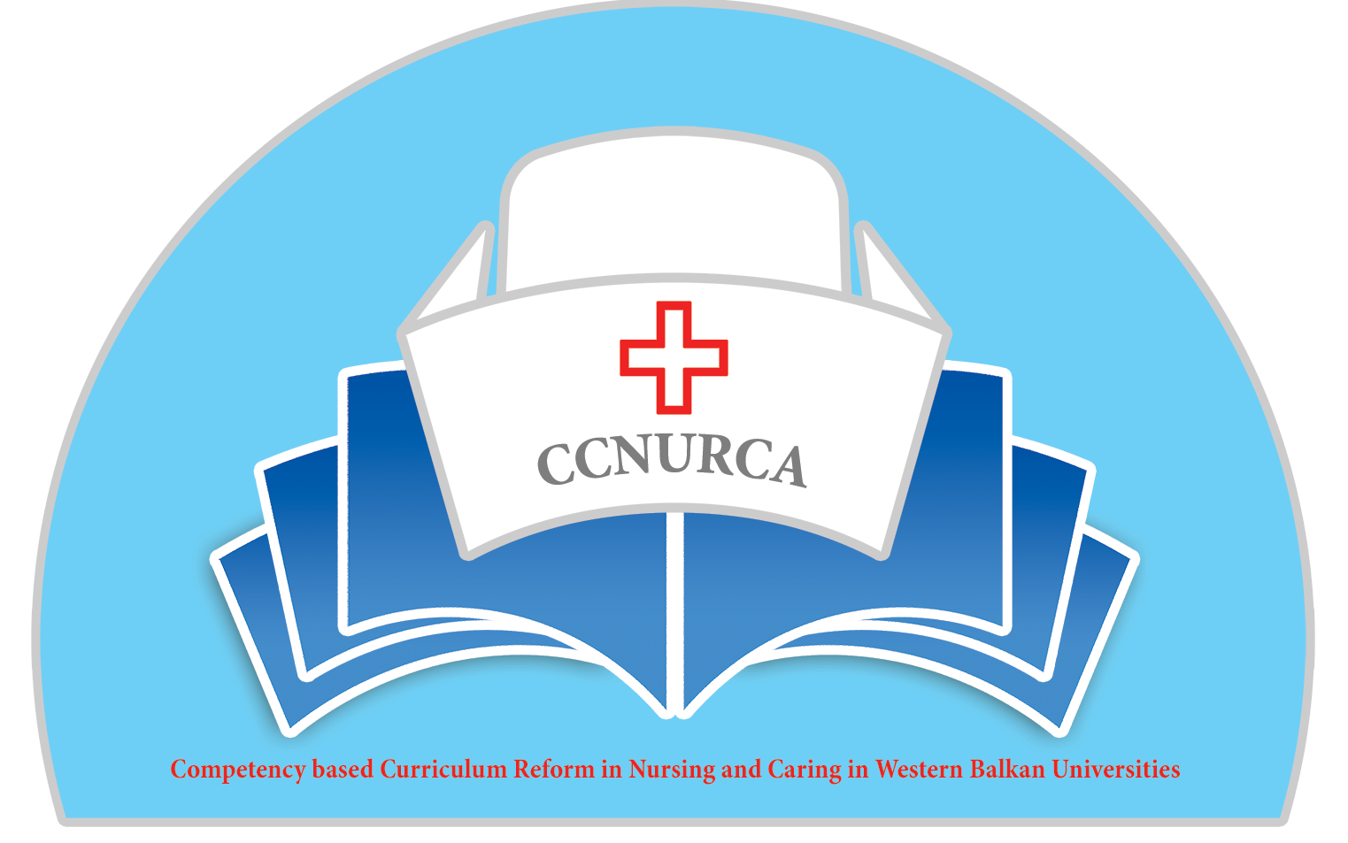

Agenda

Meeting of Steering Committee
CCNURCA project
University of Montenegro, 10-13.12.2014

Venue: University of Montenegro

Wednesday, 10 December 2014

Arrival of participants to Podgorica and travel to Budva

Thursday, 11 December 2014

09.00 Welcome

Welcome and presentation of agenda
Mr. Bogdan Asanin, UNM
Mr. Dejan Bokonjic, University of East Sarajevo
Mr. Filip Dumez, HUB KAHO

09.30-09.50 Presentation of current status of academic activities

09.50-11.20 Presentation of current status of curricula, learning outcomes and matrix of competences (Mirza Oruc-BH, Ardian Cerava Al, Bogdan Asanin Mo). /clear vision of nursing education

11.20-12.00 Coffee break

12.00-12.30 Presentation of current status of syllabi/
Dejan Bokonjic and Mirza Oruc

12.30-12.45 Current status of administrative issues-
Willem Vanden Berg

Moderator: Srdjan Masic

12.45-13.30 Lunch break

13.30-13.50 Dissemination strategies, sustainability of the
project and finding equipment-Srdjan Masic

13.50-14.10 Preparation for the Presov meeting-agenda, deadlines, responsibilities before meeting-Dejan Bokonjic

14.10-16.00 Workshop-analysis of curriculum and learning outcomes and competences -work of mentors from EU with partner countries representatives

16.00-16.30 Financial issues-current update of finances in the
project and current status of received documents
/Willem Vanden Berg

Moderator:Miorza Oruc

Moderator: Srdjan Masic

19.30 Dinner

Friday, 12 December 2014

09.00-11.00 Workshop- analysis of curriculum and learning
outcomes and competences- work of mentors from EU
with partner countries representatives/continuation from
previous day

11.00-11.30 Accreditation of study programs and acceptance by the State/ Dejan Bokonjic

11.30-12.00 Publication issues/Filip Dumez

12.00-12.30 To do list-clear tasks and responsibilities/Filip Dumez Dejan Bokonjic. Mirza Oruc and Srdjan Masic

12.30-13.00 Conclusions and closing of the training
Filip Dumez and Dejan Bokonjic

13.00-14.00 Lunch break

Saturday, 13 December2014

Departure of participants

