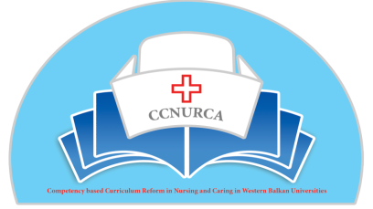
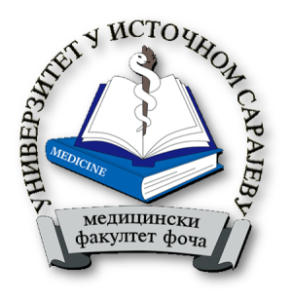

SEMINAR
Nursing practical skills

Medical faculty Foca, 16.05.2016

9.30-9.45 Presentation of agenda –Prof dr Dejan Bokonjić / Učionica 302
9.45-10.30 Problem based learning- Prof. dr Maja Račić/ Učionica 302
10.30-11.45 Campus-computer based learning –Mr Srđan Mašić /Računarski centar 202
11.45-12.15 Break
12.15-13.00 Payton-Mr Natalija Hadživuković, Mr Sanja Joković, Mr Jelena Pavlović / Učionica 302
13.00-13.45 OSCE - Mr Natalija Hadživuković, Mr Sanja Joković, Mr Jelena Pavlović/ Učionica 302
13.45-14.15 Break
14.15-15.00 Debriefing –prof.dr Dejan Bokonjić / Učionica 302
15.00-15.45 Mind Mapping- Mr Jelena Pavlović / Učionica 302
15.45-16.15 Discussion

Seminar is organized inside project Competency based Curriculum Reform in Nursing and Caring in Western Balkan Universities (CCNURCA)-
544169-TEMPUS-1-2013-1-BE-TEMPUS-JPCR
http://www.ccnurca.eu/
Participants:
Representatives University of East Sarajevo, Podgorica, Mostar and Zenica.

