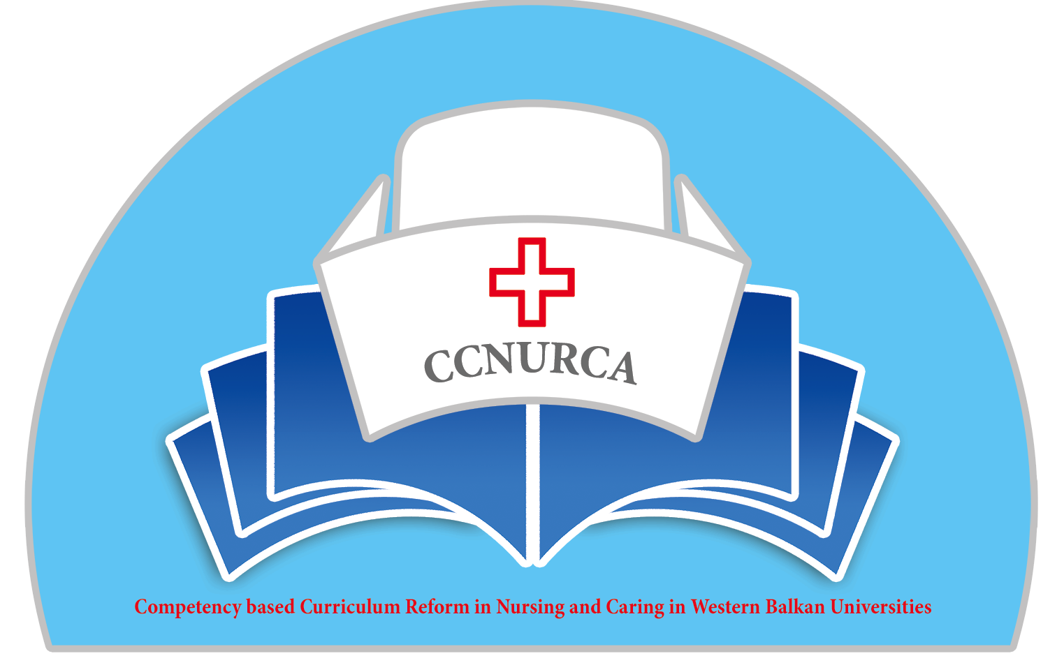

Agenda

Meeting
CCNURCA project
University College, 9-10.07.2015

Venue: Odisee University College, Warmoesberg 26, meeting room 6109

Wednesday, 8 July 2015
Arrival of participants

18.00 – 20.00 Preparation of the LP’s monitoring meeting in Albania

Thursday, 9 July 2015

09.00 Welcome and presentation of the agenda
Candice de Windt Filip Dumez Dejan Bokonjic

09.15 - 9.30 Purpose, target audience and high level planning of the training in Shkodra
Dejan Bokonjic Mirza Oruc

9.30 - 9.45 Cultural issues to take into account during the training
Dejan Bokonjic Mirza Oruc

9.45 - 10.15 Learning needs following the curriculum reform in the WB countries (incl. reprise of ‘Analysis of current situation in the WB’)
Dejan Bokonjic Mirza Oruc Filip Dumez

Proposals of content and teaching methods for the training

10.30 - 11.00 Simulation and debriefing as a method to improve non-technical skills and attitude
Patrick Janssens

11.00 - 11.15 Coffee break

11.15 - 11.45 Clinical skills training using case studies and mind mapping, a method to improve critical thinking and ability to plan nursing interventions
Lubica Rybarova Stefania Andrascikova

11.45 - 12.15 Learning principles, reflection and communication skills
Maarten Kaaijk Johan Wieren

12.15 - 13.15 Lunch break

13.15 - 13.45 Practical skills and internship training
Maarten Kaaijk Johan Wieren

13.45 - 14.15 Alternative teaching methods (part 1)
Kathy Pletinckx

14.15 - 14.45 Alternative teaching methods (part 2)
Lieselot Van Droogenbroeck

14.45 - 15.00 Coffee break

15.00 - 15.30 OSCE stations and four step Payton methodology
Dejan Bokonjic Mirza Oruc

Practical planning and organization of the training

15.30 - 17.30 Practical planning and organization of the training in Shkodra
Group discussion

Moderator: Mirza Oruc

17.30 - 17.45 Conclusion of the day-
Filip Dumez and Dejan Bokonjic

19.00 Official dinner

Friday, 10 July 2015.

09.30 Welcome

Welcome and presentation of agenda
Filip Dumez

9.45 - 11.45. Refining the practical planning and organization of the training in Shkodra
Group discussion

Moderator: Mirza Oruc

11.45 - 12.30 Presentation of the final training schedule for the training in Shkodra (content, needs, travelling schedule,…)
Dejan Bokonjic

12.30 - 12.45 Conclusion of the day
Filip Dumez and Dejan Bokonjic

12.45 - 13.30 Lunch break

13.30 - 16.30. Sightseeing tour in Brussels (optional)

Departure of participants

