Agenda
Train the trainer seminar
544169–TEMPUS–1–2013-1-BE-TEMPUS-JPCR
Competency based Curriculum Reform in Nursing and Caring in Western Balkan Universities
Dates: 06-10 September 2015
Venue: University of Skhodra

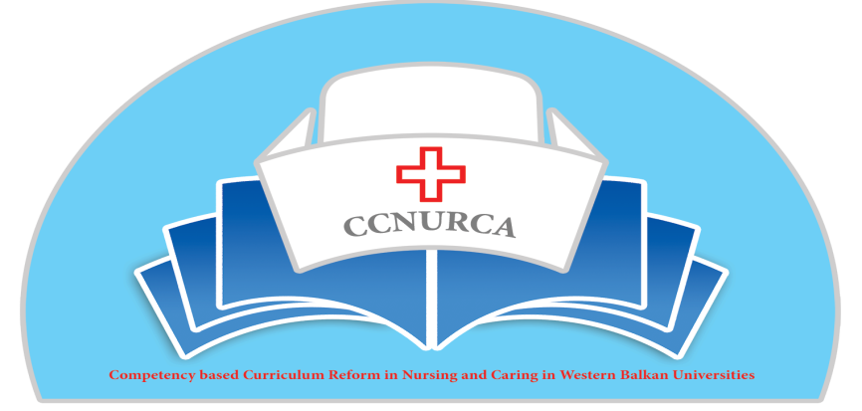

Activity: Practical training for teaching and examining methodologies in nursing

10th of July 2015.
- Presentation of the agenda by Filip Dumez and Prof. dr. Dejan Bokonjic.
- Refining the practical planning and organisation of the training in Shkodra.
- The schedule below represents the practical program
7/9/'15 | 8/9/'15 | 10/9/'15
9:00- 10:00  Introduction and presentation of the agenda  Expectations: Bokonjic, Dumez, Oruc, Cerava | 9:00-9:15  Presentation of the agenda (Masic) | 9:45- 10:00  Presentation of the agenda (Cerava)
10:00-10:30  Plenary session  Overview of alternative teaching methods. (Kathy Pletinckx and Lieselot Van Droogenbroeck) | 9:15-10:15  Plenary session  Debriefing (Patrick Janssens) | 10:00-10:30  Plenary session  PBL (Maarten Kaaijk and Johan Wieren)
10:30-11:00  Plenary session  Mind map. ( Lubica Rybarova and Stefania Andrascikova. | 10:15-11:15  4 groups, rotation system  1 group: Workshop debriefing (Patrick Janssens)  1 group: Plenary session: Communication skills (Damir Kukic)  1group: Plenary session: Campus (Srdjan Masic)  1 group: lunch  Legend:  Debriefing, Patrick Janssens  Campus: Srdjan Masic  Communication skills: Kukic  Lunch | 10:30-12:00  Workshop PBL  3 groups  Maarten, Johan and Dejan
  10:15- 11:15 | I | II | III | IV
  11: 15- 11:30 Coffee break
  11: 30- 12:30 | II | I | III | IV
  12:30- 13:30 | IV | I | III | II
  13:30- 14:30 | IV | II | III | I
11:00-11:30  Coffee break | 14:45- 16:30  Reflection | 12:00-13:00  Lunch
11:30-13:00  Workshop  4 groups, 2 different workshops, rotating system, WS 1: Alternative teaching methods, given by 2 trainers.  WS 2: Mind mapping, given by 2 trainers. | 16:30  Conclusion | 13:00-13:45  Plenary session  Payton + OSCE  13:45-15:30  Workshop Payton + OSCE  4 groups
  11:30- 13:00 | SK  Lubica | SK  Stefania | B  Lieselot | B  Kathy
  14:00- 15:30 | B  Lieselot | B  Kathy | SK  Lubica | SK  Stefania
13:00-14:00 Lunch break | 17:15 Trainer meeting | 15:30- 16:15  Reflections
14:00-15:30 Workshop | 18:00 Social event + dinner | 16:15  Ceremony and certification
15:30-15:45 Coffee break
16:00- 17:00
Plenary session: reflection
Trainer meeting
19:00 Social event
20:00 Dinner

Participants

Mostar team:
Kristina Vidović
Olivera Perić
Anka Zelenika

Zenica team :
Oruč Mirza
Kenan Galijašević
Adnan Mujezinović
Harun Hodžić

East Sarajevo team:

Racic Maja
Natalija Hadzivukovic
Jelena Pavlovic
Dejan Bokonjic
Srdjan Masic

Montenegro team:

Bogdan Asanin
Nataša Duborija- Kovacevic
Alma Bajramspahic
Mirka Kneževic

Fami:

Biljana Božić
Tatjana Ašćerić
Amer Ovčina
Darija Kneežević

Skhodra team:
Mr. Julian Kraja
Mr. Emiljano Pjetri
Mr. Sebastian Mjekaj
Mrs. Silvana Belisha
Mrs. Valbona Dibra

Gjorikastra team:

Luiz Seiti
Bledar Late
Zamira Vllaho
Arjeta Xhemali

Korca team still missing:
Korca 1
Korca 2
Korca 3
Korca 4

Odisee team

Kathy Pletinckx
Lieselot Van Droogenbroeck
Patrick Janssens
Filip Dumez

Groningen team

Martin Kaaik
Johan van Wieren

Presov team

Lubica Rybarova
Stephania Andrascikova

Grupe:
Yellow 1
Blue 2
Green 3
Grey 4

Racic Maja UES
Olivera Perić Mostar
Anka Zelenika Mostar
Kenan Galijašević Zenica
Harun Hodžić Zenica
Amir Denjalić Zenica
Luiz Seiti Gjirokastra

Natalija Hadzivukovic UES
Jelena Pavlovic UES
Kristina Vidović Mostar
Adnan Mujezinović Zenica
Nataša Duborija- Kovacevic CG
Biljana Božić Fami
Tatjana Ašćerić Fami

Alma Bajramspahic CG
Mirka Kneževic CG
Amer Ovčina Fami
Darija Kneežević Fami
Mr. Julian Kraja Shkoder
Mr. Emiljano Pjetri Shkoder
Korca 1
Korca 2

Mr. Sebastian Mjekaj
Mrs. Silvana Belisha
Mrs. Valbona Dibra
Bledar Late
Zamira Vllaho
Arjeta Xhemali
Korca 3
Korca 4

